Name: Arupriya

Roll no.: 2019307

Examination roll no.: 19066570006

MACHINE LEARNING PRACTICAL

Q1: Perform elementary mathematical operations in Python like addition, multiplication, division and exponentiation.

CODE:

x=int(input("Enter number 1: "))

y=int(input("Enter number 2: "))

print("Results after elementary maths operations:------")

print("Addition: ",x+y)

print("Subtraction: ",x-y)

if(y!=0):

print("Division: ",x/y)

else:

print("Division not possible!!")

print("Multiplication: ",x*y)

print("Exponent: ",x**y)

OUTPUT:

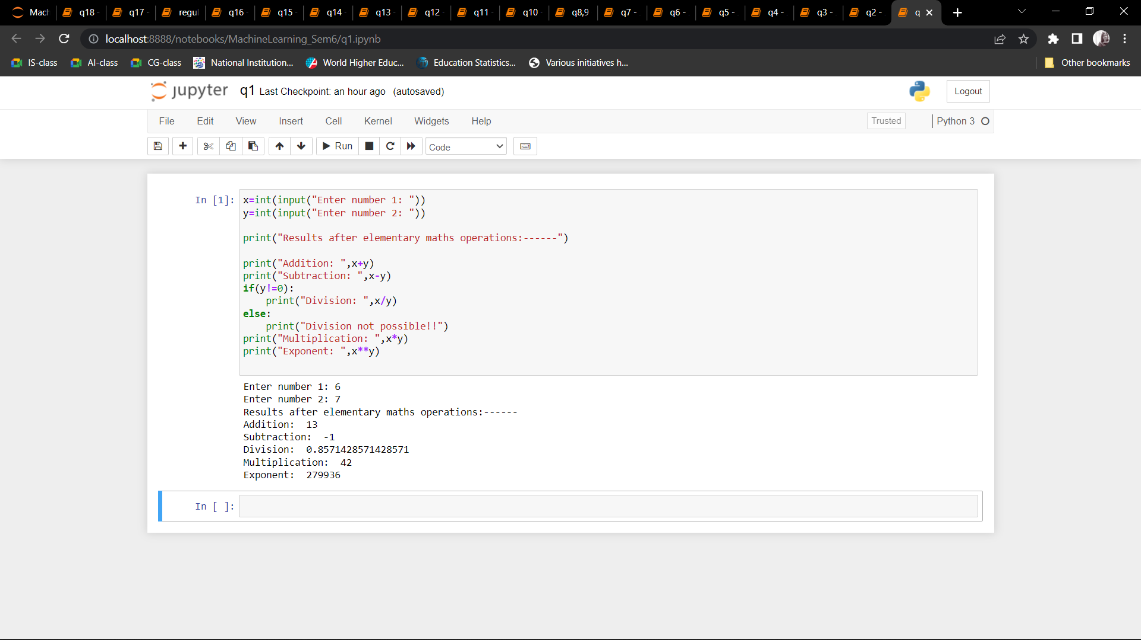

Q2: Perform elementary logical operations in Python (like OR, AND, Checking for  Equality, NOT, XOR).

CODE:

x=int(input("Enter number 1: "))

y=int(input("Enter number 2: "))

print("Results after boolean operations:------")

print("AND :",x and y)

print("OR :",x or y)

print("Checking Equality :",x==y)

print("NOT of number 1 :",not x)

print("NOT of number 2 :",not y)

print("XOR :",x^y)

OUTPUT:

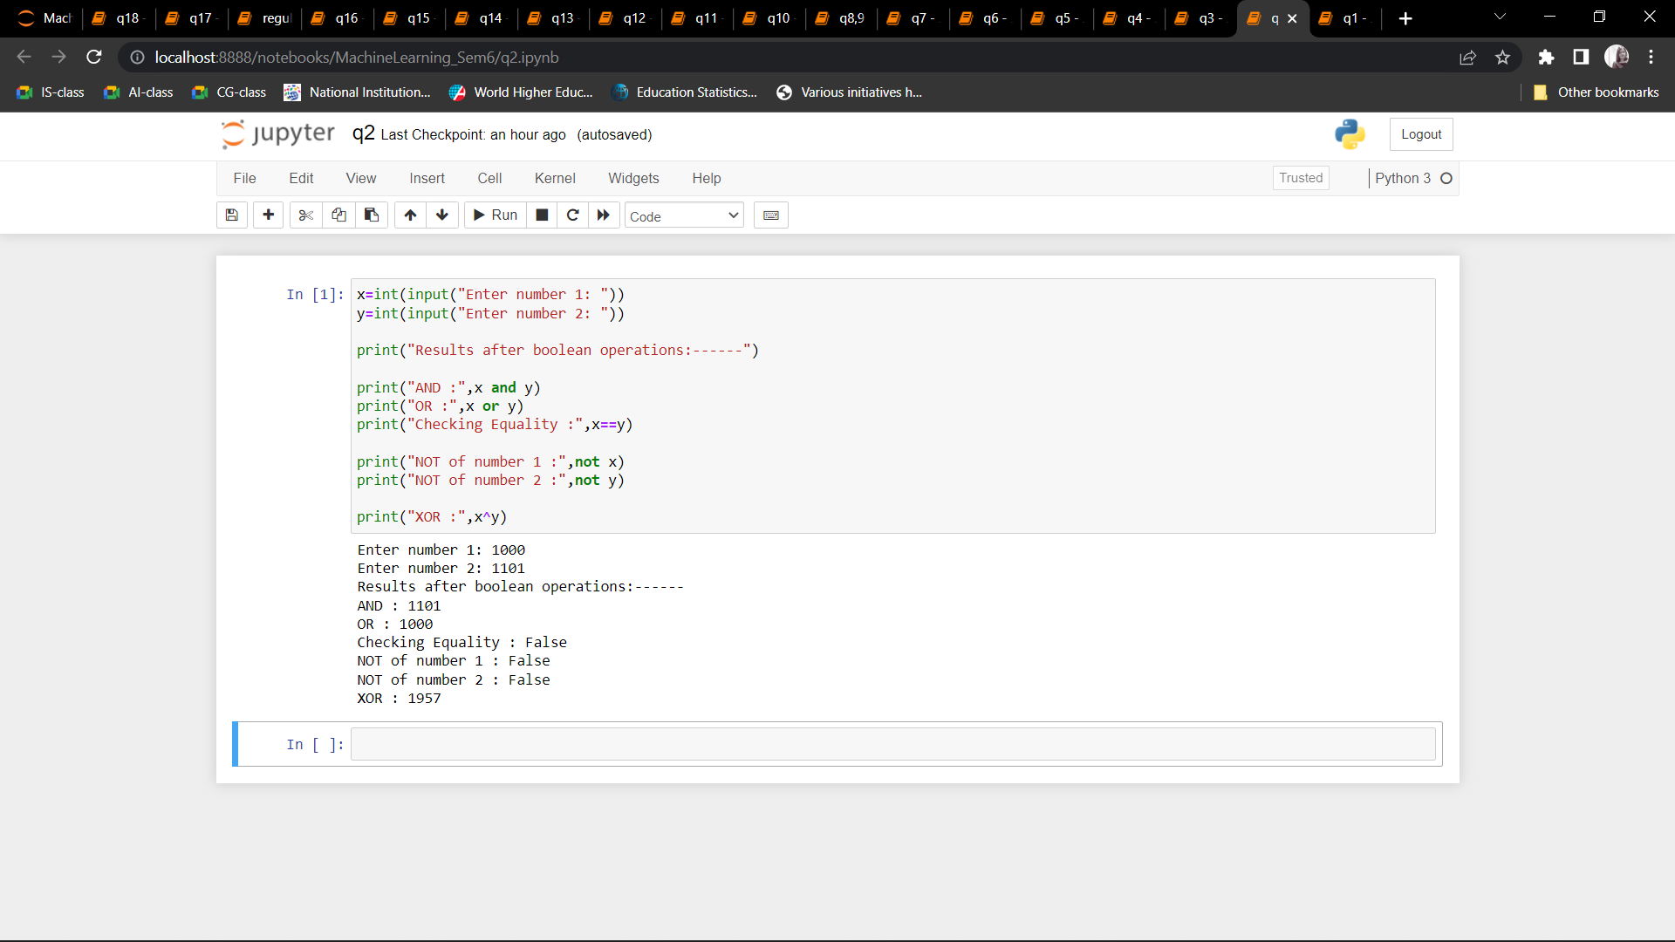

Q3: Create, initialize and display simple variables and simple strings and use simple formatting for variable.

CODE:

x= 2/3

z=16

y= """ My Name is Arupriya.

Hello Everyone """

print("----------------------String Formatting---------------------")

print(x)

print(y.split())

print(y.splitlines())

print(y.strip())

print(y.upper())

print(y.lower())

print(y.capitalize())

print(y.title())

print("_".join(y.split()))

print()

print("----------------------Number Formatting----------------------")

print(int(x))

print("%0.3f"%(x))

print(hex(z))

print(bin(z))

print(oct(z))

OUTPUT:

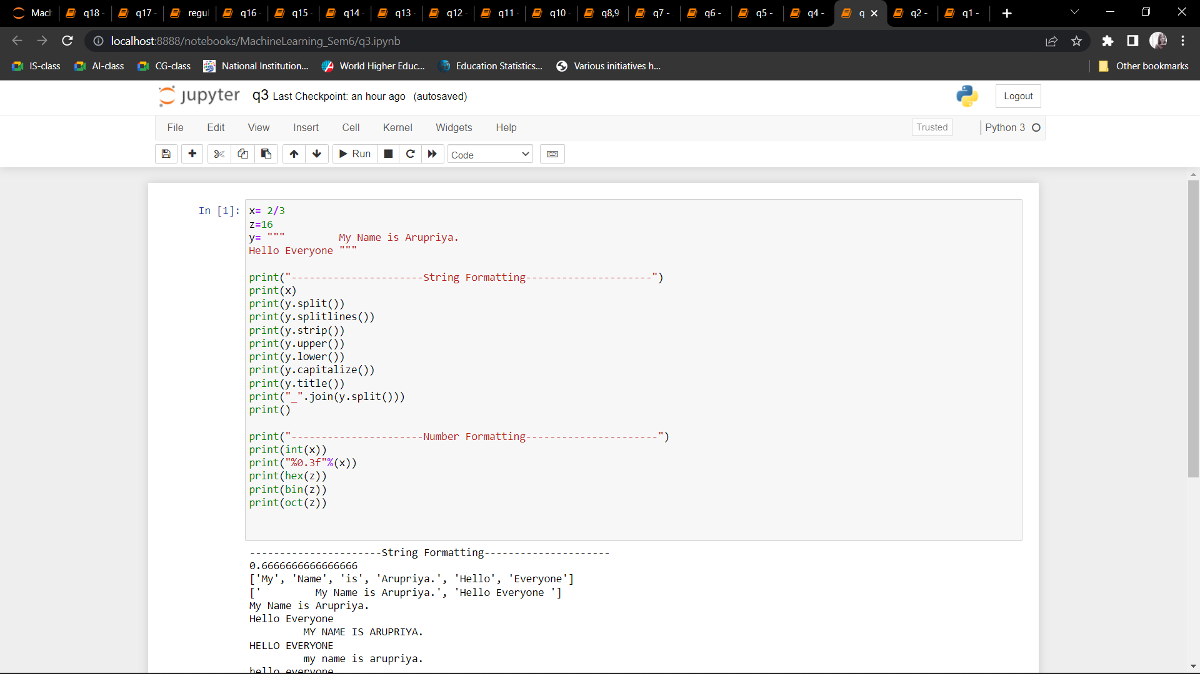

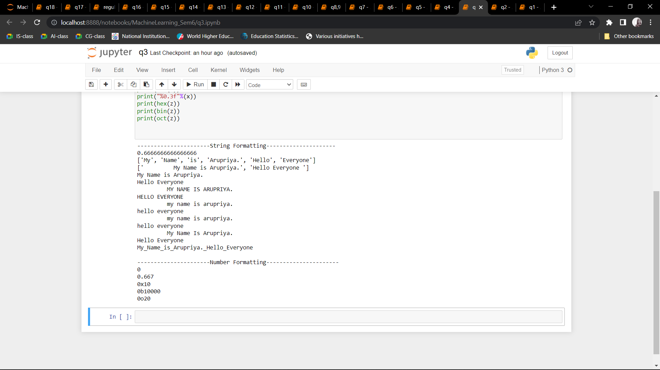

Q4: Create/Define single dimension / multi-dimension arrays, and arrays with specific values like array of all ones, all zeros, array with random values within a range, or a diagonal matrix.

CODE:

import numpy as np

print('----------------------Single Dimensional Array ----------------------')

print('With all zeroes')

print(np.zeros(5,int))

print()

print('With all ones')

print(np.ones(5,int))

print()

print('With all random integers')

print(np.random.randint(1,10,5))

print()

print('With values within a range')

print(np.arange(1,10))

print()

print('----------------------Multi Dimensional Array----------------------')

print('With all zeroes')

print(np.zeros((4,3),int))

print()

print('With all ones')

print(np.ones((4,3),int))

print()

print('With all random integers')

print(np.random.randint(1,10,(4,3)))

print()

print('With values within a range')

print(np.arange(1,10).reshape(3,3))

print()

print('With diagonal element')

print(np.eye(4,None,0,int))

print()

OUTPUT: 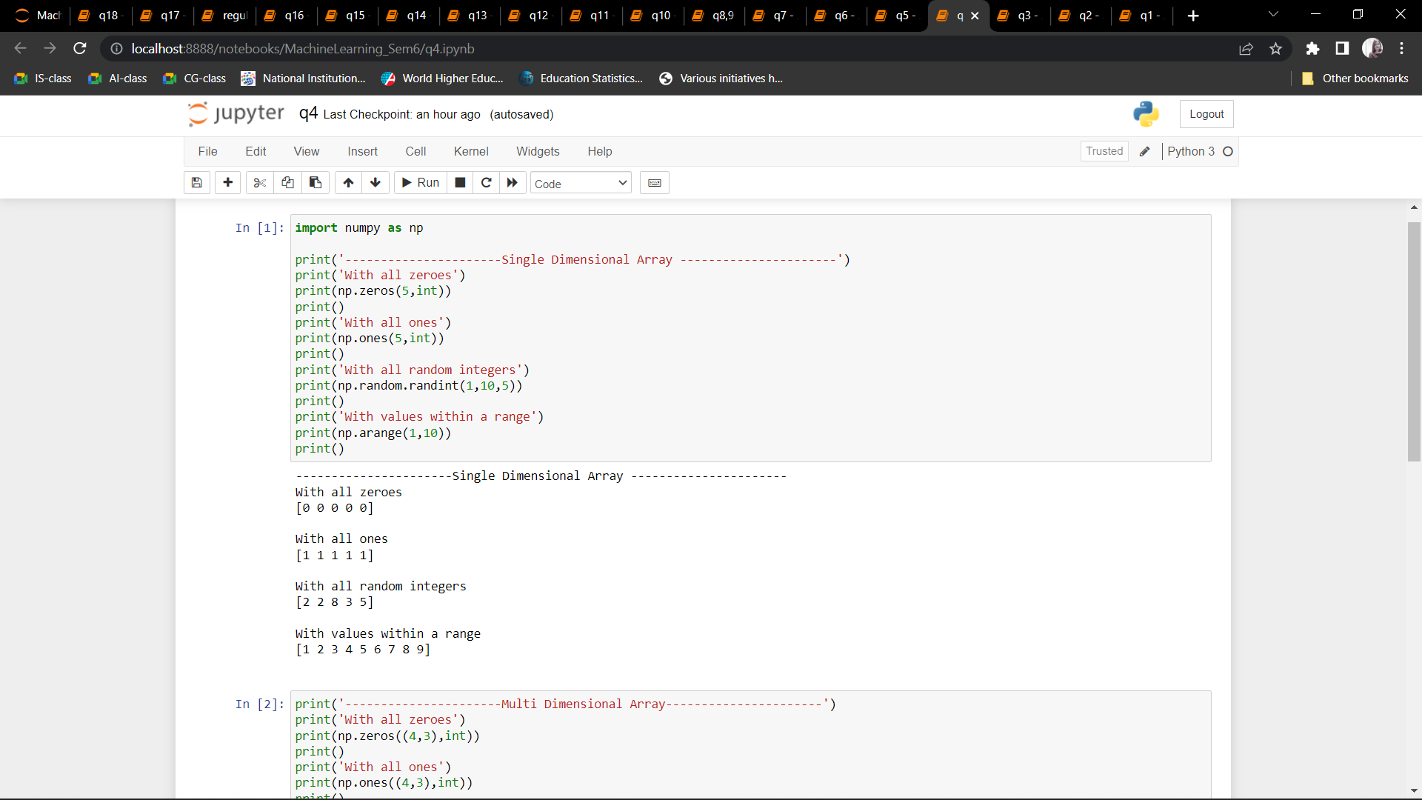 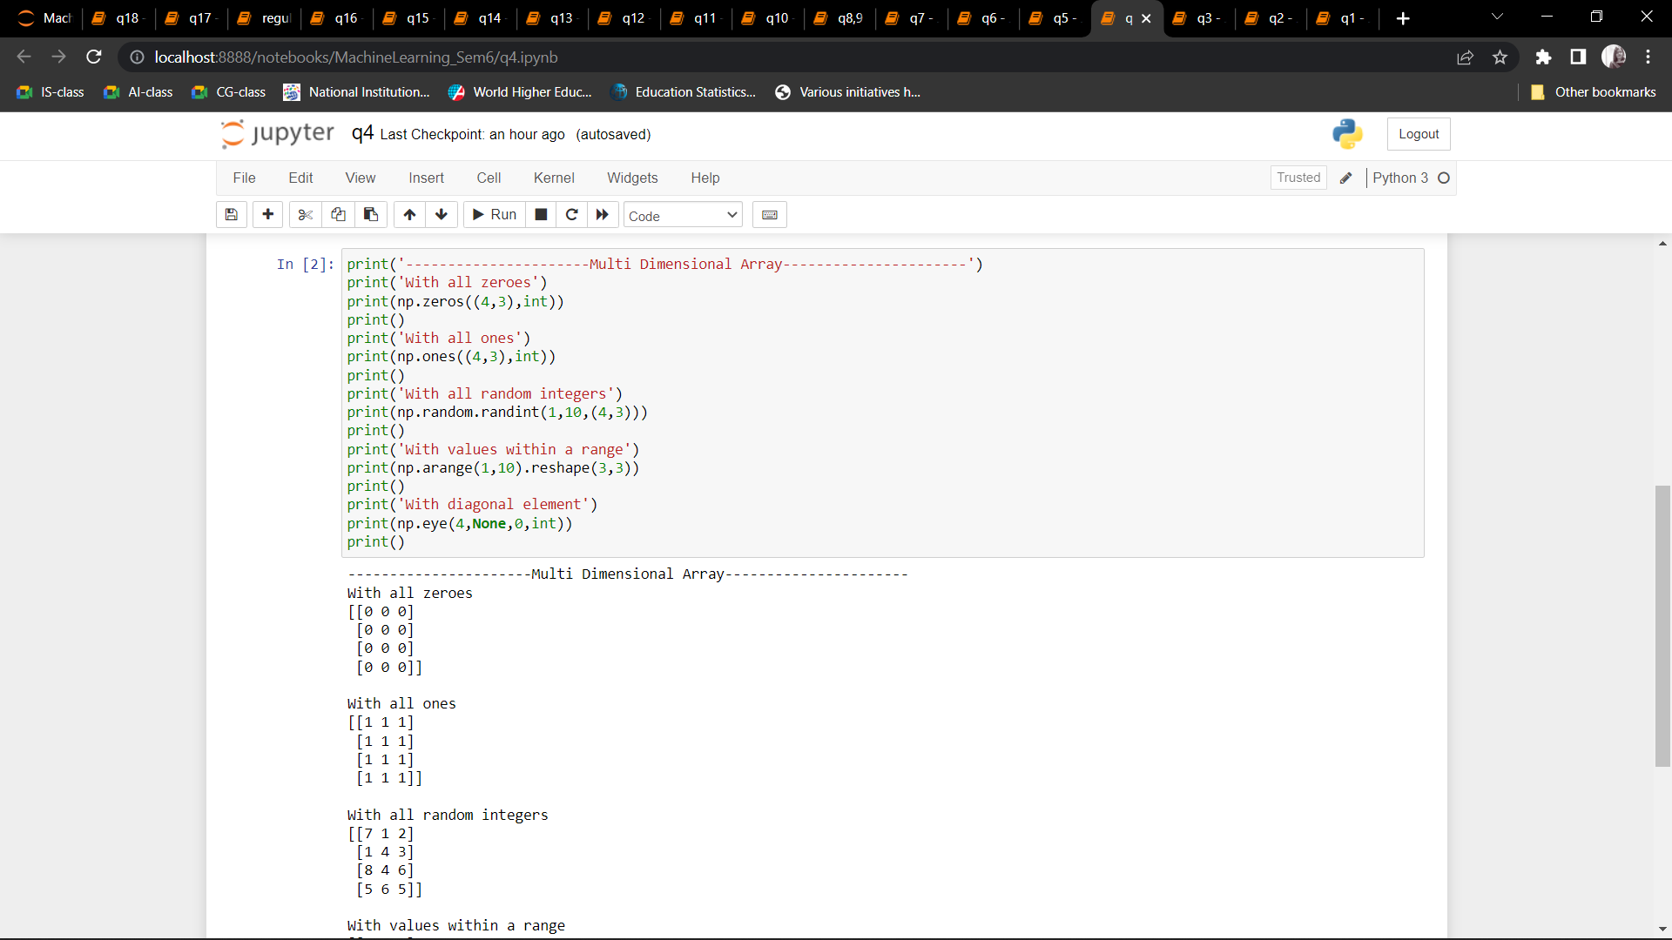

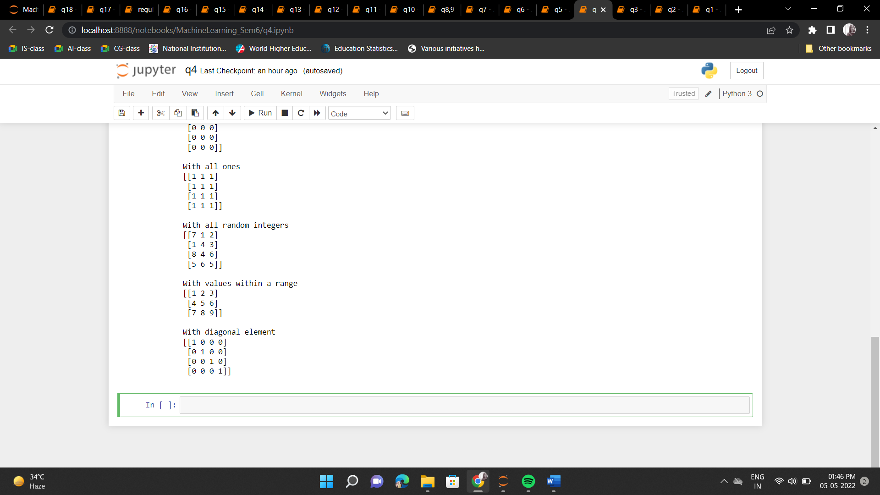

Q5: Use command to compute the size of a matrix, size/length of a particular row/column, load data from a text file, store matrix data to a text file, finding out variables and their features in the current  scope.

CODE:

import numpy as np

arr=np.random.randn(4,3)

print('Array:')

print('---------------------------------------------------------------------------')

print(arr)

print()

print('Size of Array:')

print('---------------------------------------------------------------------------')

print(arr.size)

print()

print('Size of particular row (row 2):')

print('---------------------------------------------------------------------------')

print(len(arr[:,2]))

print()

print('Size of particular column (column 2):')

print('---------------------------------------------------------------------------')

print(len(arr[2,:]))

print()

print('Taking input from file: ')

print('---------------------------------------------------------------------------')

with open('numpy2text.txt', 'r') as f:

l =np.loadtxt(f)

print(l)

print()

print('Saving Array to a file: ')

print('---------------------------------------------------------------------------')

with open('numpy2output.txt', 'wb') as f:

np.savetxt(f,arr)

print("Done!")

OUTPUT: 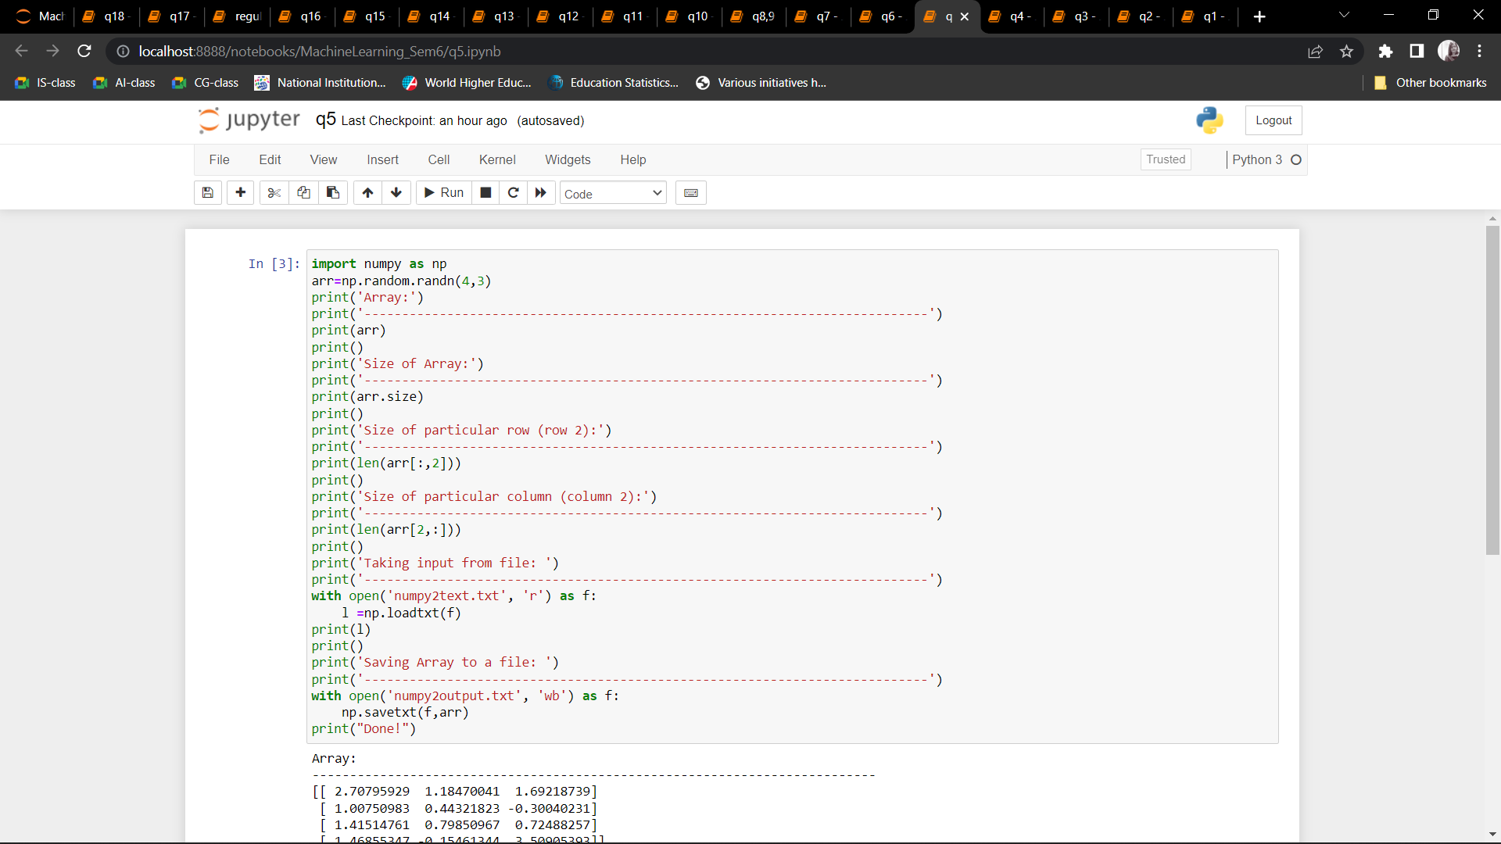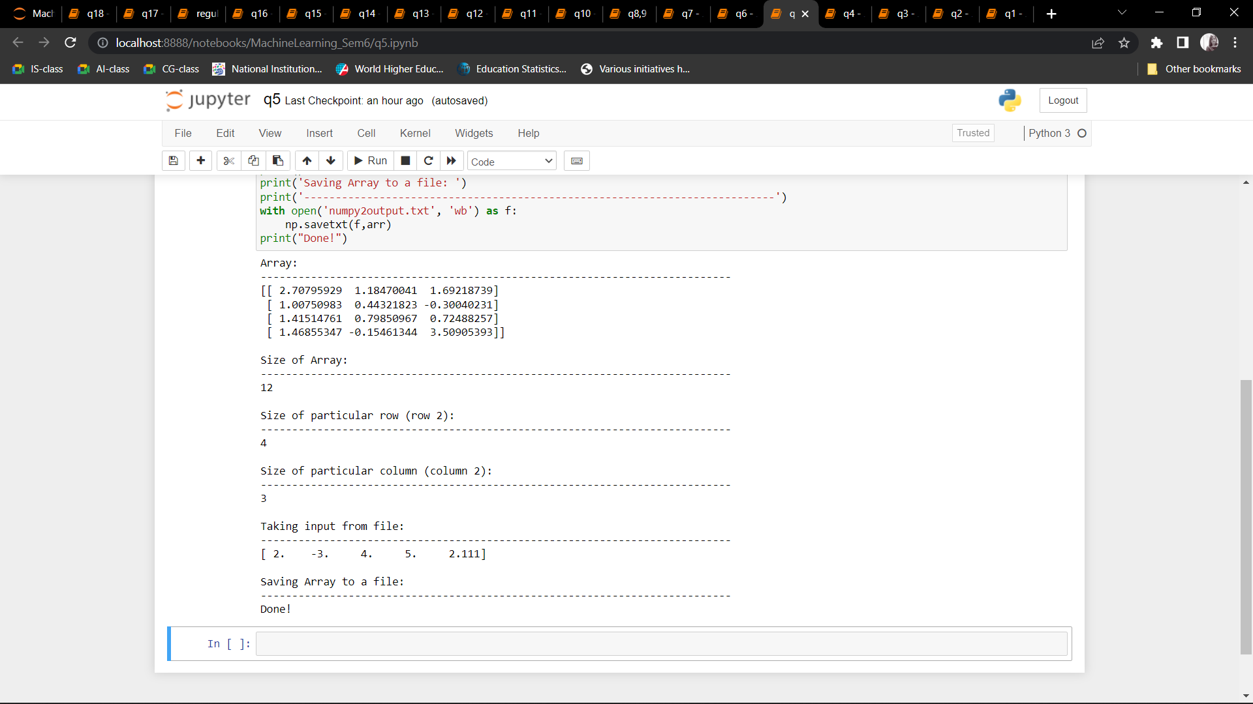

Q6: Perform basic operations on matrices (like addition, subtraction, multiplication) and display specific rows or columns of the matrix.

CODE:

import numpy as np

mat1= np.random.randint(1,10,(3,3))

mat2= np.random.randint(1,10,(3,3))

print("Matrix 1:")

print(mat1)

print("Matrix 2:")

print(mat2)

print()

print('Addition of Two matrices')

print('---------------------------------------------------------------------------')

mat3=mat1+mat2

print(mat3)

print()

print('Subtraction of Two matrices')

print('---------------------------------------------------------------------------')

mat3=mat1+mat2

print(mat3)

print()

print('Multiplication of Two matrices')

print('---------------------------------------------------------------------------')

mat3=mat1*mat2

print(mat3)

print()

mat1= np.random.randint(1,10,(4,3))

mat2= np.random.randint(1,10,(3,2))

print("Matrix 1:")

print(mat1)

print("Matrix 2:")

print(mat2)

print()

print('Element-by-Element Multiplication of Two matrices')

print('---------------------------------------------------------------------------')

mat3=mat1.dot(mat2)

print(mat3)

print()

print('Displaying Specific Rows and column')

print('---------------------------------------------------------------------------')

print(mat3[1:,1:])

OUTPUT: 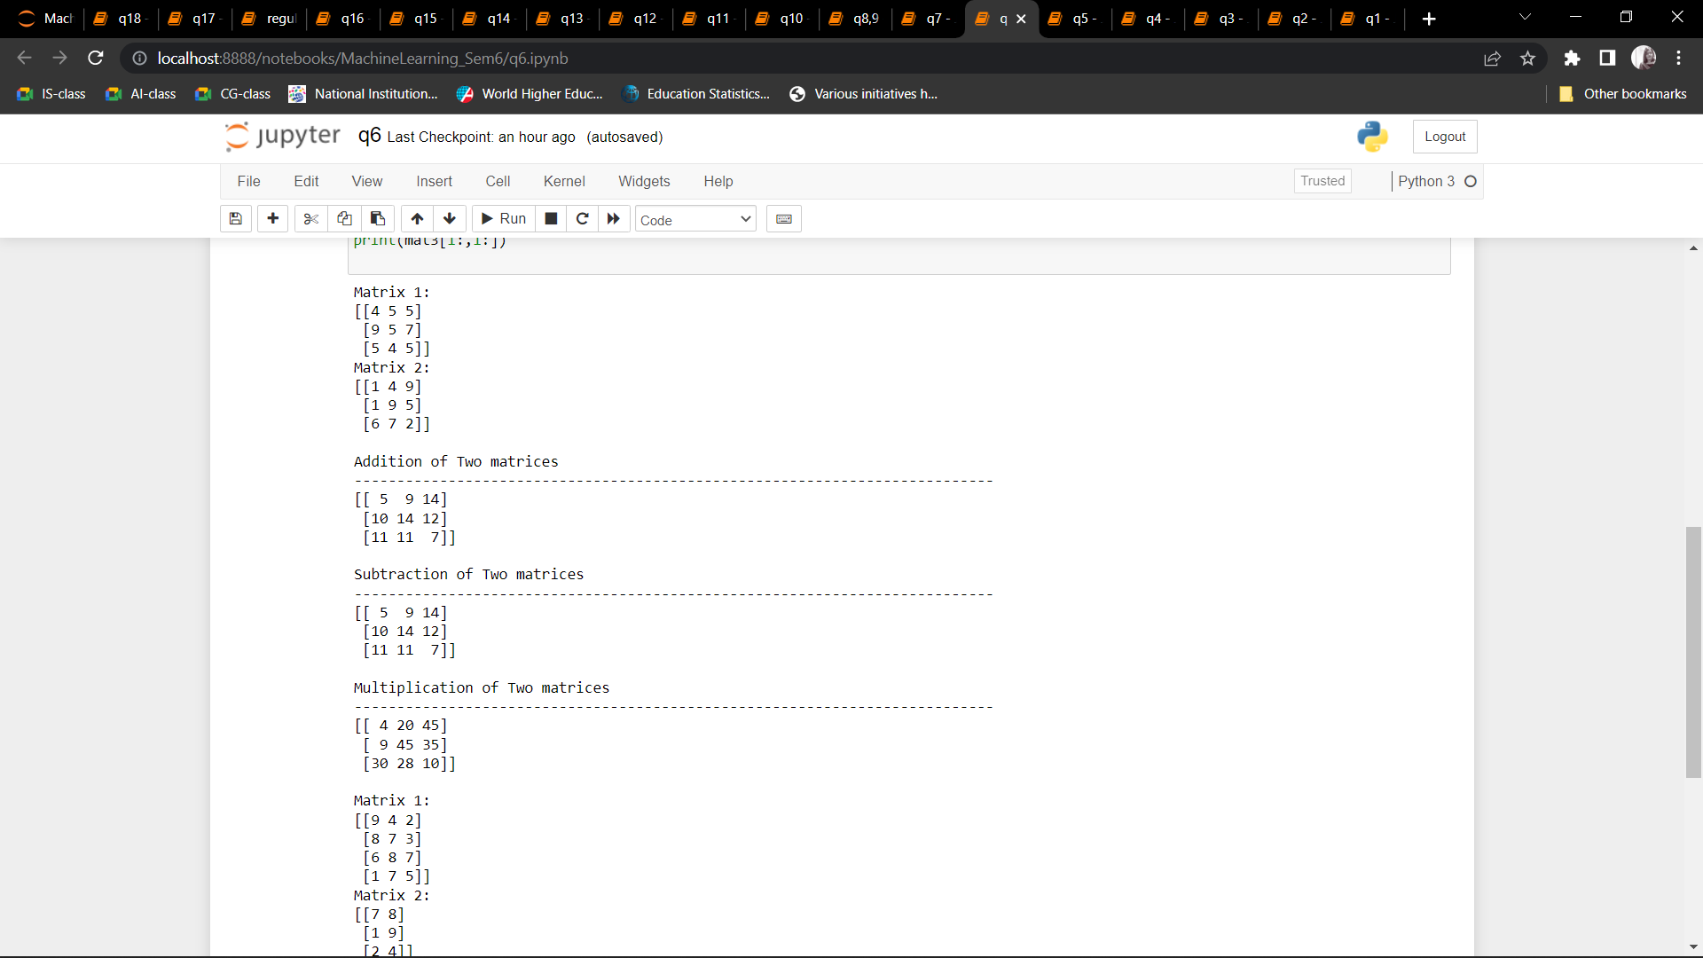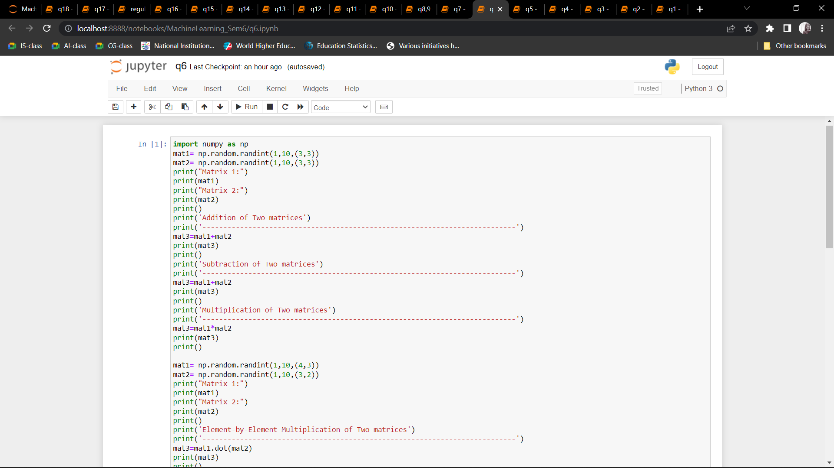 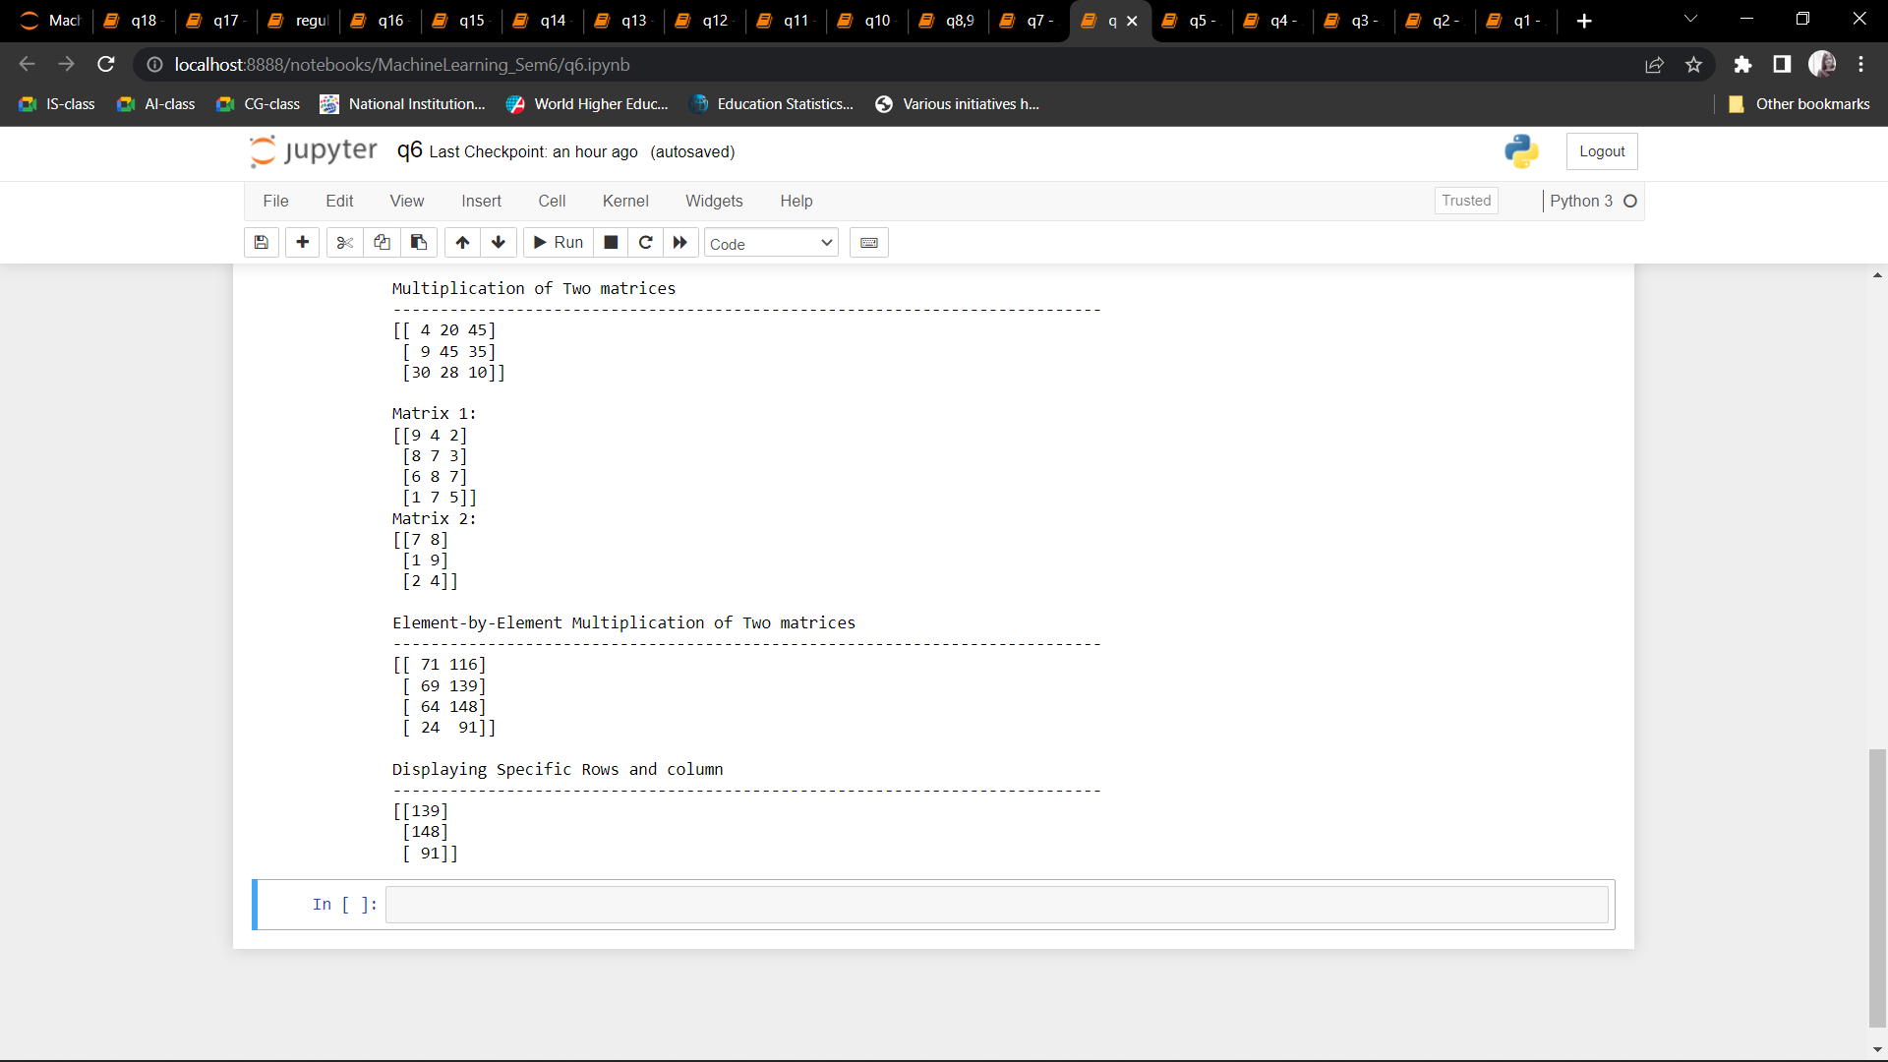

Q7: Perform other matrix operations like converting matrix data to absolute values, taking the negative of matrix values, additing/removing rows/columns from a matrix, finding the maximum or minimum values in a matrix or in a row/column, and finding the sum of some/all elements in a matrix.

CODE:

import numpy as np

arr=np.random.randn(4,3)

print('Array:')

print('---------------------------------------------------------------------------')

print(arr)

print()

print('Absolute Value of the Array')

print('---------------------------------------------------------------------------')

print(np.absolute(arr))

print()

print('Negative Value of the Array')

print('---------------------------------------------------------------------------')

print(np.negative(arr))

print()

print('Array after deleting row 2')

print('---------------------------------------------------------------------------')

print(np.delete(arr,2,0))

print()

print('Array after deleting column 2')

print('---------------------------------------------------------------------------')

print(np.delete(arr,2,1))

print()

print('Maximum of Array')

print('---------------------------------------------------------------------------')

print(np.max(arr))

print()

print('Minimum of Array')

print('---------------------------------------------------------------------------')

print(np.min(arr))

print()

print('Sum of all elements of Array')

print('---------------------------------------------------------------------------')

print(np.sum(arr))

print()

print('Sum of all elements of Array row-wise')

print('---------------------------------------------------------------------------')

print(np.sum(arr,0))

print()

print('Sum of all elements of Array column-wise')

print('---------------------------------------------------------------------------')

print(np.sum(arr,1))

OUTPUT: 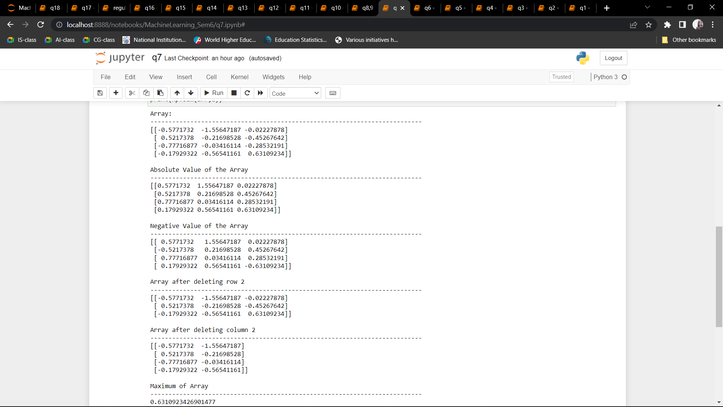 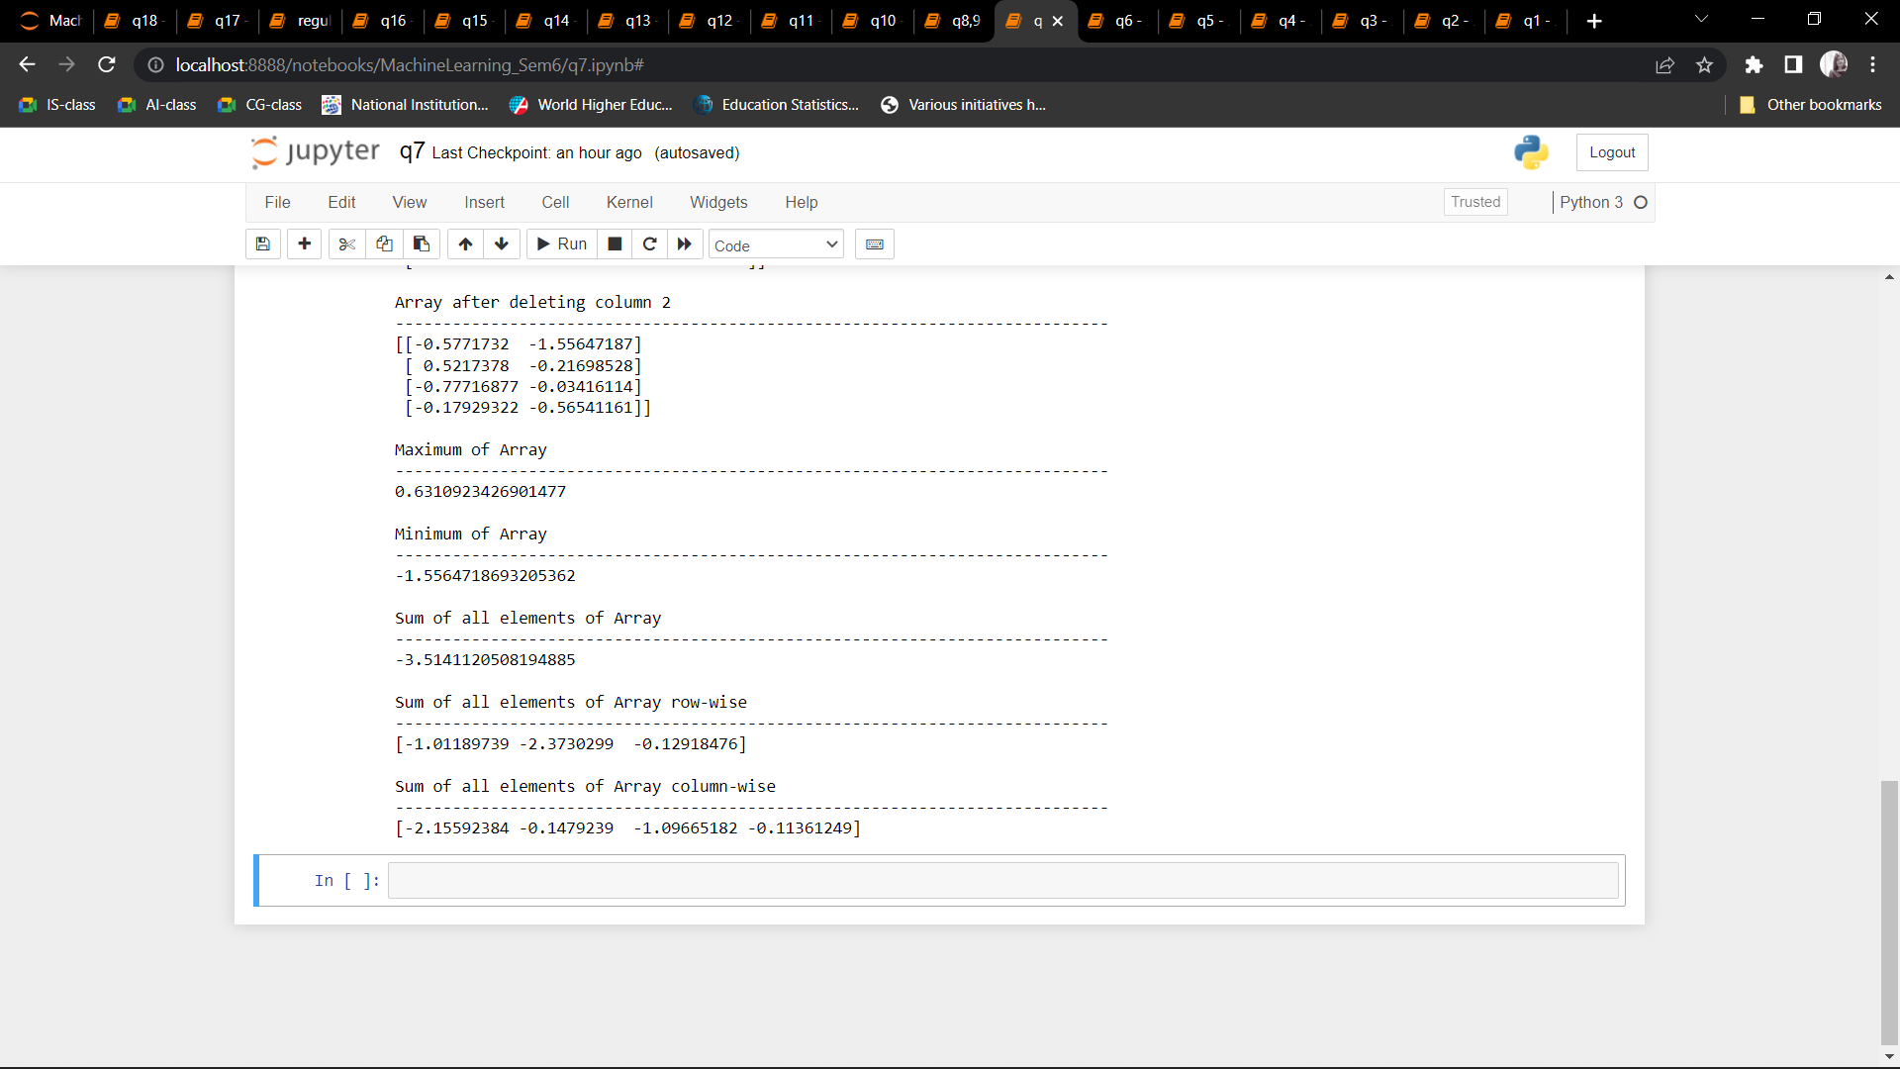

Q8: Create various type of plots/charts like histograms, plot based on sine/cosine function based on data from a matrix. Further label different axes in a plot and data in a plot.

Q9. Generate different subplots from a given plot and color plot data.

CODE:

import matplotlib.pyplot as plt

import numpy as np

x=np.arange(40)

x

plt.plot(x)

plt.show()

y=np.sin(x)

plt.plot(x)

plt.plot(y)

plt.show()y=np.cos(x)

plt.plot(x,color='red')

plt.plot(y)

plt.show()

x=np.array([1,2,3,4,5])

y=x**2

plt.scatter(x,y,color="purple", label="squares of number", marker="o") #color, label, marker are optional arguments

plt.legend()

plt.xlabel("numbers")

plt.ylabel("squares")

plt.show()

x=np.array([1,2,3,4,5])

plt.plot(x,x**2,label="squares of number", marker="o")

plt.plot(x,x**3,label="cubes of number", marker="o")

plt.legend()

plt.xlabel("numbers")

plt.title("Squares and Cubes")

plt.show()

numbers=np.random.randint(0,10,5)

indices=np.arange(5)

indices=indices+2015

numbers2=np.random.randint(0,10,5)

indices2=np.arange(5)

indices2=indices2+2015

print(numbers)

print(numbers2)

plt.bar(indices,numbers,0.25,color="pink",label="rainfall")

plt.bar(indices2+0.25,numbers2,0.25,color="cyan",label="humidity")

plt.legend()

plt.show()

labels=["english","german","maths","science","social science","computers"]

values=[90,80,40,73,78,43]

plt.pie(values,labels=labels,radius=1)

plt.show()

plt.pie(values,labels=labels,radius=1,explode=(0,0,1,0,0,0),shadow=True)

plt.show()

u=5

sigma=2

vals=u+sigma*np.random.randn(1000)

print(vals.shape)

plt.hist(vals,50)

plt.show()

plt.figure(figsize=(8,8))

plt.subplot(221)

plt.plot(x,x**2, label="2018")

plt.plot(x,x**3, label="2017")

plt.subplot(222)

plt.hist(vals,50)

plt.subplot(223)

plt.pie(values,labels=labels,radius=1)

plt.subplot(224)

plt.pie(values,labels=labels,radius=1,explode=(0,0,1,1,0,1),shadow=True)

plt.show()

OUTPUT:

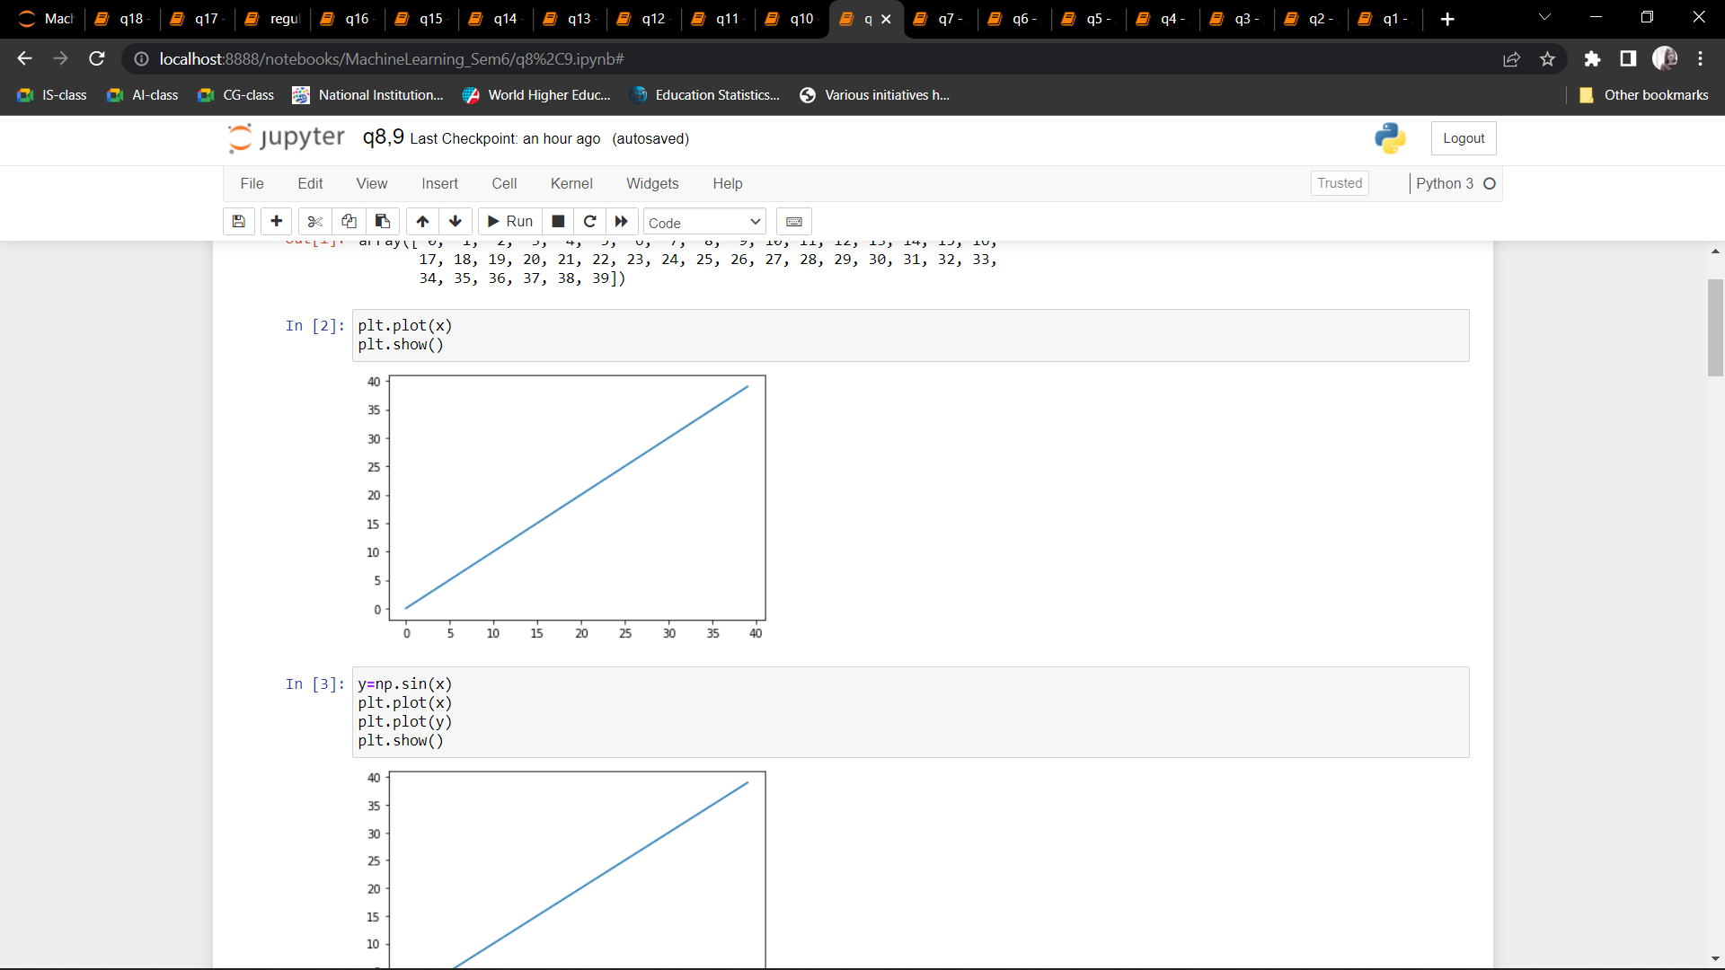 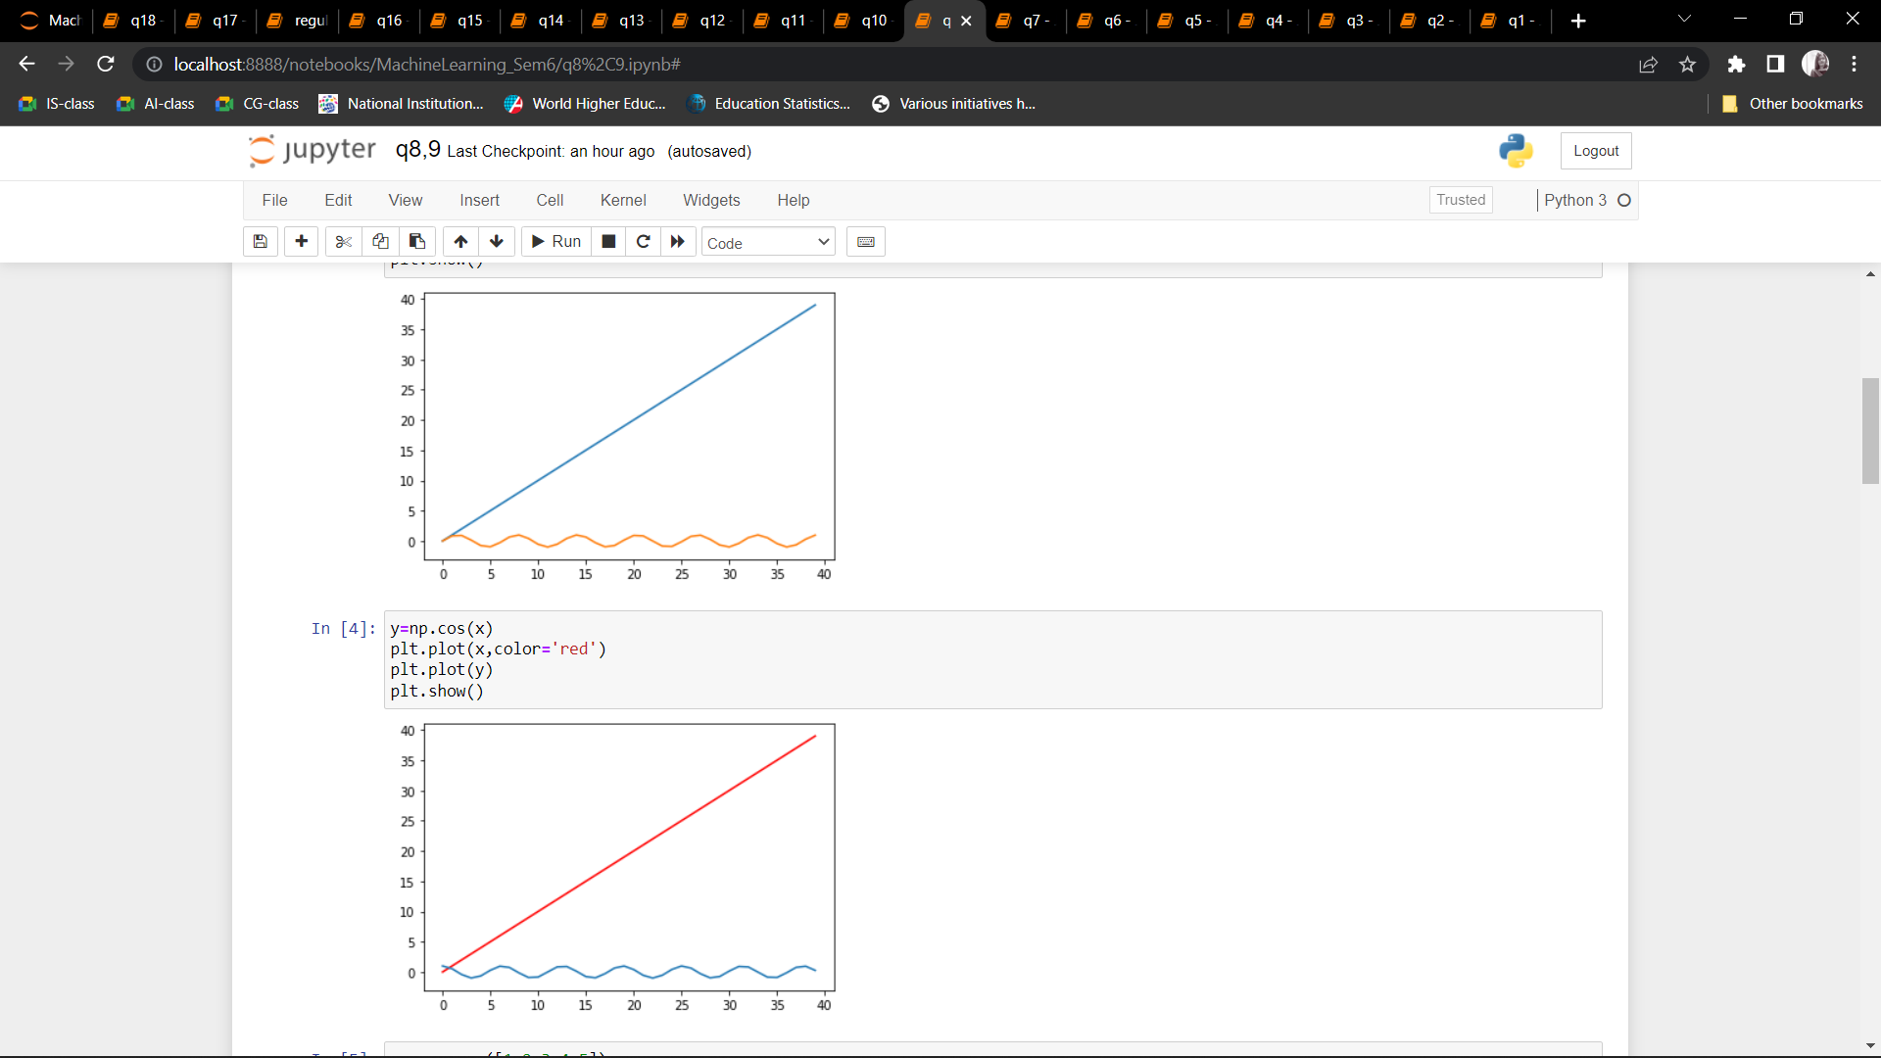 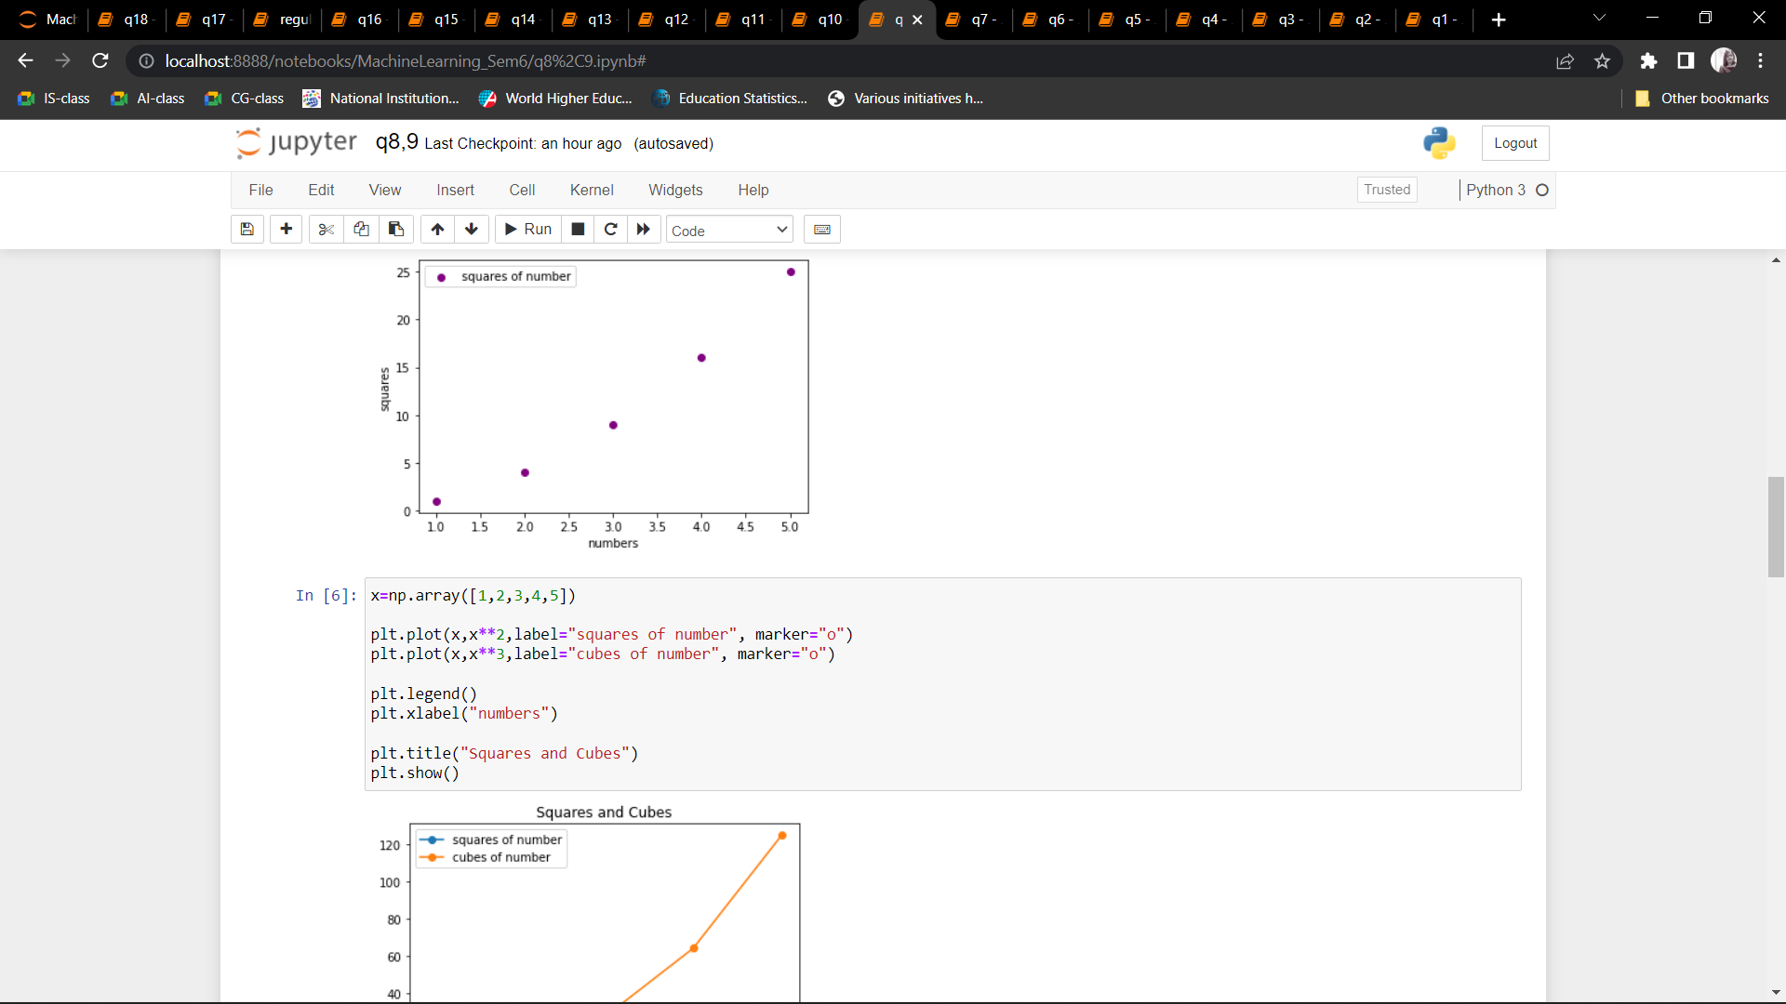 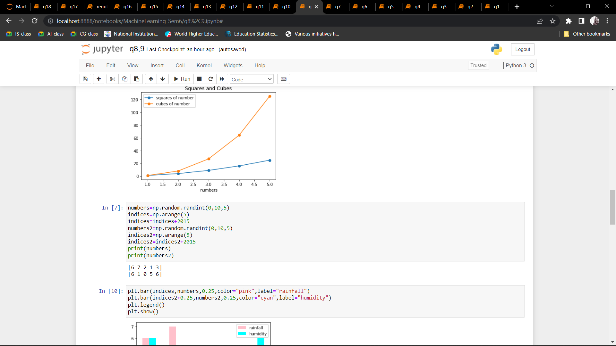 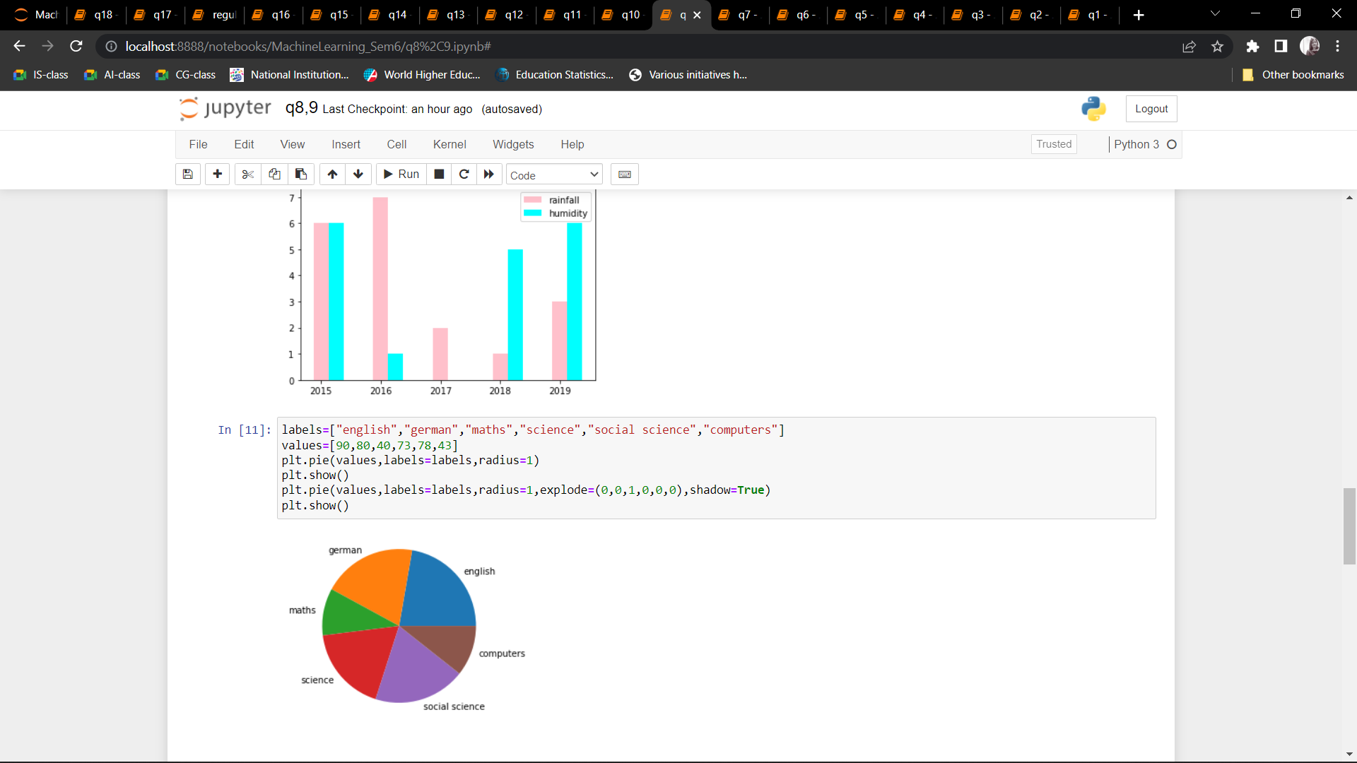 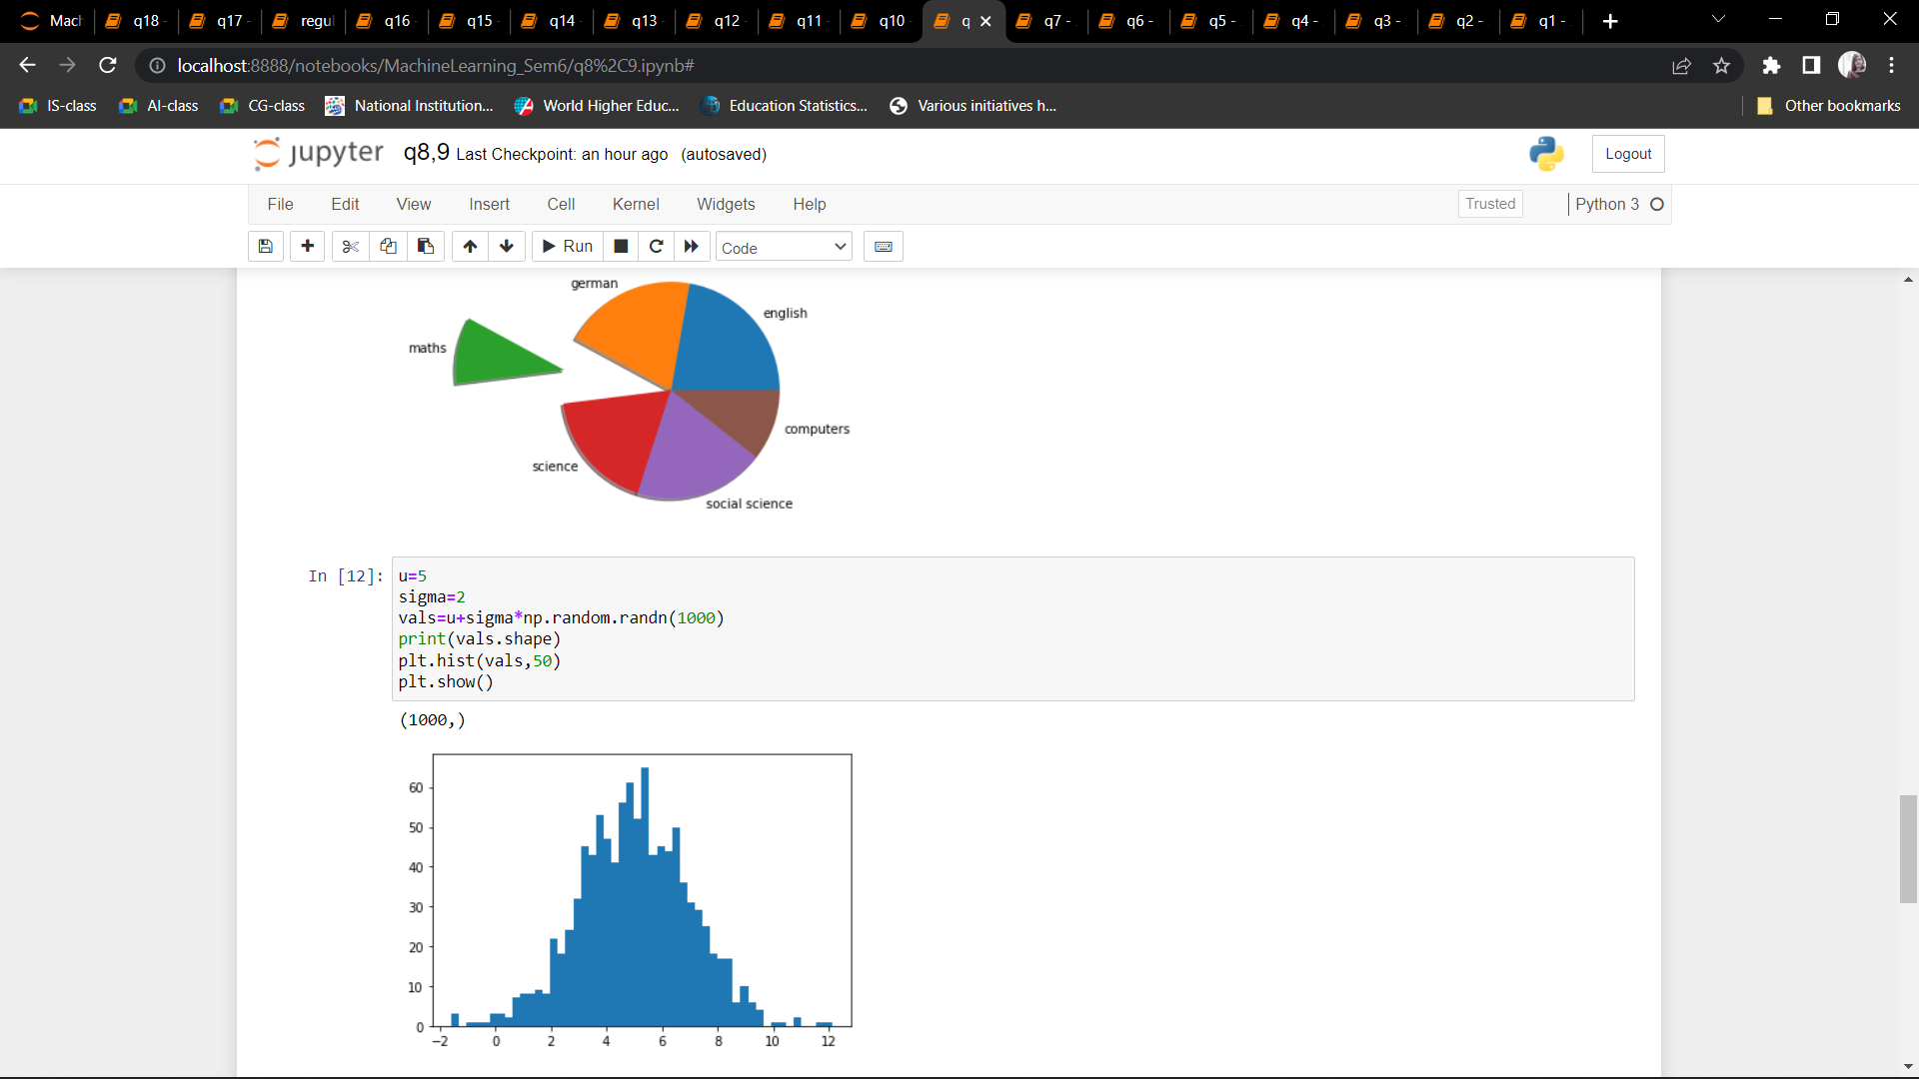 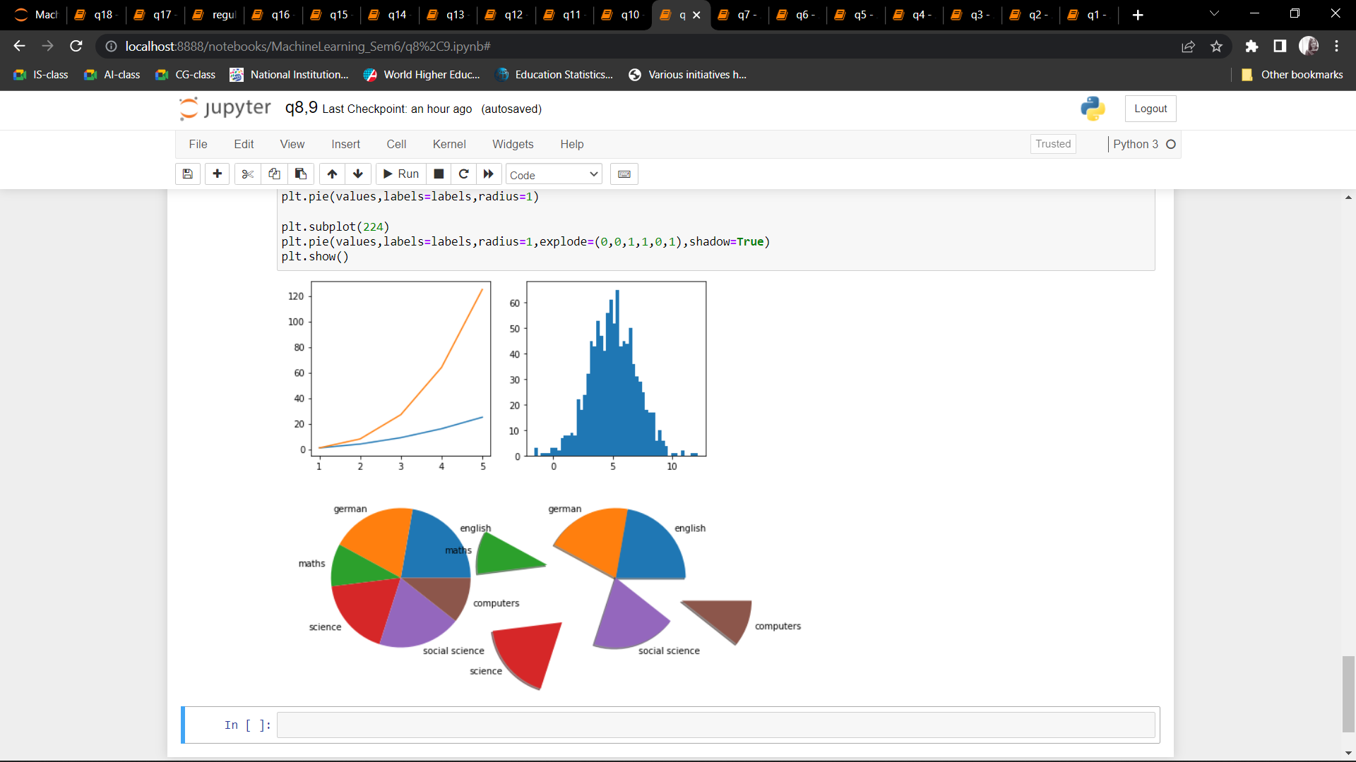

Q10: Use conditional statements and different type of loops based on simple example/s.

CODE:

A = [[1, 2, 3],

[4, 5, 6],

[7, 8, 9]]

B = [[10, 11, 12, 13],

[14, 15, 16, 17],

[18, 19, 20, 21]]

result = [[0, 0, 0, 0],

[0, 0, 0, 0],

[0, 0, 0, 0]]

for i in range(len(A)):

for j in range(len(B[0])):

for k in range(len(B)):

result[i][j] += A[i][k] * B[k][j]

for i in range(len(result)):

for j in range(len(result[0])):

print(result[i][j],end=" ")

print()

OUTPUT:

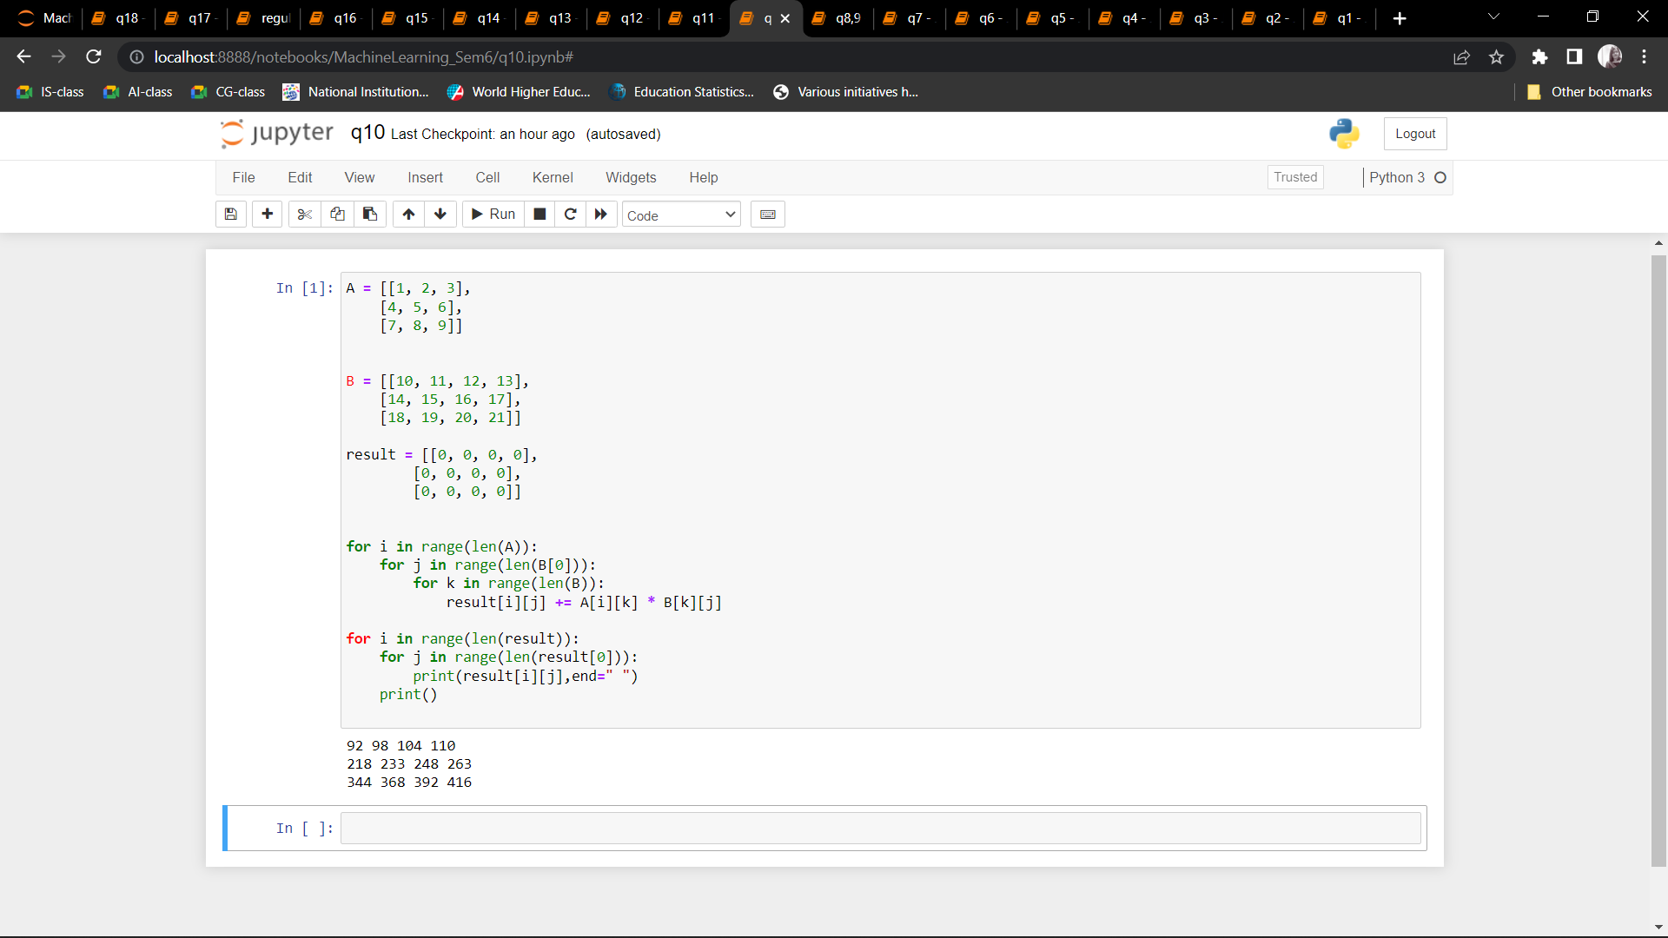

Q11: Perform vectorized implementation of simple matrix operation like finding the transpose of a  matrix, adding, subtracting or multiplying two matrices.CODE:

import matplotlib.pyplot as plt

time=[0,1,2,3]

position=[0,100,200,300]

plt.plot(time,position)

plt.xlabel('Time(hr)')

plt.ylabel('Position(km)')

plt.show()

plt.plot([1,2,3,4],[1,4,9,16],'ro')

plt.axis([0,6,0,20])

plt.show()

#categorical plotting

names=['part1','part2','part3']

values=[1,10,100]

plt.figure(figsize=(9,3))

plt.subplot(131)

plt.bar(names,values)

plt.subplot(132)

plt.scatter(names,values)

plt.subplot(133)

plt.plot(names,values)

plt.show()

import numpy as np

x = np.linspace(0, 10, 50)

plt.plot(x, np.sin(x),'red')

plt.plot(x, np.cos(x),'blue')

plt.style.use('classic')

plt.show()

plt.savefig('my_figure.png')

plt.figure() # create a plot figure

# create the first of two panels and set current axis

plt.subplot(2, 1, 1) # (rows, columns, panel number)

plt.plot(x, np.sin(x))

# create the second panel and set current axis

plt.subplot(2, 1, 2)

plt.plot(x, np.cos(x));

#dot product

import numpy as np

import time

a = np.arange(100)

b = np.arange(100)

# pure Python outer product implementation

tic = time.process_time()

dot_product = 0

for i in range(len(a)):

dot_product += a[i] * b[i]

toc = time.process_time()

print("python_dot_product = "+ str(dot_product))

print("Time = "+str(1000*(toc - tic ))+"ms\n")

# Numpy outer product implementation

n_tic = time.process_time()

dot_product = np.dot(a, b)

n_toc = time.process_time()

print("numpy_dot_product = "+str(dot_product))

print("Time = "+str(1000*(n_toc - n_tic ))+"ms")

#outer product

import time

import numpy

import array

a = array.array('i')

for i in range(200):

a.append(i);

b = array.array('i')

for i in range(200, 400):

b.append(i)

# classic outer product of vectors implementation

tic = time.process_time()

outer_product = numpy.zeros((200, 200))

for i in range(len(a)):

for j in range(len(b)):

outer_product[i][j]= a[i]*b[j]

toc = time.process_time()

print("outer_product = "+ str(outer_product));

print("Computation time = "+str(1000*(toc - tic ))+"ms")

n_tic = time.process_time()

outer_product = numpy.outer(a, b)

n_toc = time.process_time()

print("outer_product = "+str(outer_product));

print("\nComputation time = "+str(1000*(n_toc - n_tic ))+"ms")

#element wise multiplication

import time

import numpy

import array

a = array.array('i')

for i in range(50000):

a.append(i);

b = array.array('i')

for i in range(50000, 100000):

b.append(i)

vector = numpy.zeros((50000))

tic = time.process_time()

for i in range(len(a)):

vector[i]= a[i]*b[i]

toc = time.process_time()

print("Element wise Product = "+ str(vector));

print("\nComputation time = "+str(1000*(toc - tic ))+"ms")

n_tic = time.process_time()

vector = numpy.multiply(a, b)

n_toc = time.process_time()

print("Element wise Product = "+str(vector));

print("\nComputation time = "+str(1000*(n_toc - n_tic ))+"ms")

import numpy as np

v1= np.array([[1,2,3],[4,5,6],[7,8,9]])

v2= np.array([[5,8,3],[2,5,7],[9,4,2]])

#addition

sum= np.add(v1,v2)

print("addition: \n",sum)

#multiplication

result = [[0, 0, 0],

[0, 0, 0],

[0, 0, 0]]

for i in range(len(v1)):

for j in range(len(v2[0])):

for k in range(len(v2)):

result[i][j] += v1[i][k] * v2[k][j]

print("\n multiplication:\n")

for r in result:

print(r)

#transpose

print("\n transpose:\n",sum.T)

#inverse

print("\n inverse:\n",np.linalg.inv(v1))

import numpy as np

v1= np.array([1,2,3,4])

v2= np.array([5,8,3,3])

#addition

sum= np.add(v1,v2)

print("addition: ",sum)

#multiplication

mult=np.multiply(v1,v2)

print("multiplication: ",mult)

#transpose

a = np.array([5,4])[np.newaxis]

print(a)

print("transpose:\n",a.T)

OUTPUT: 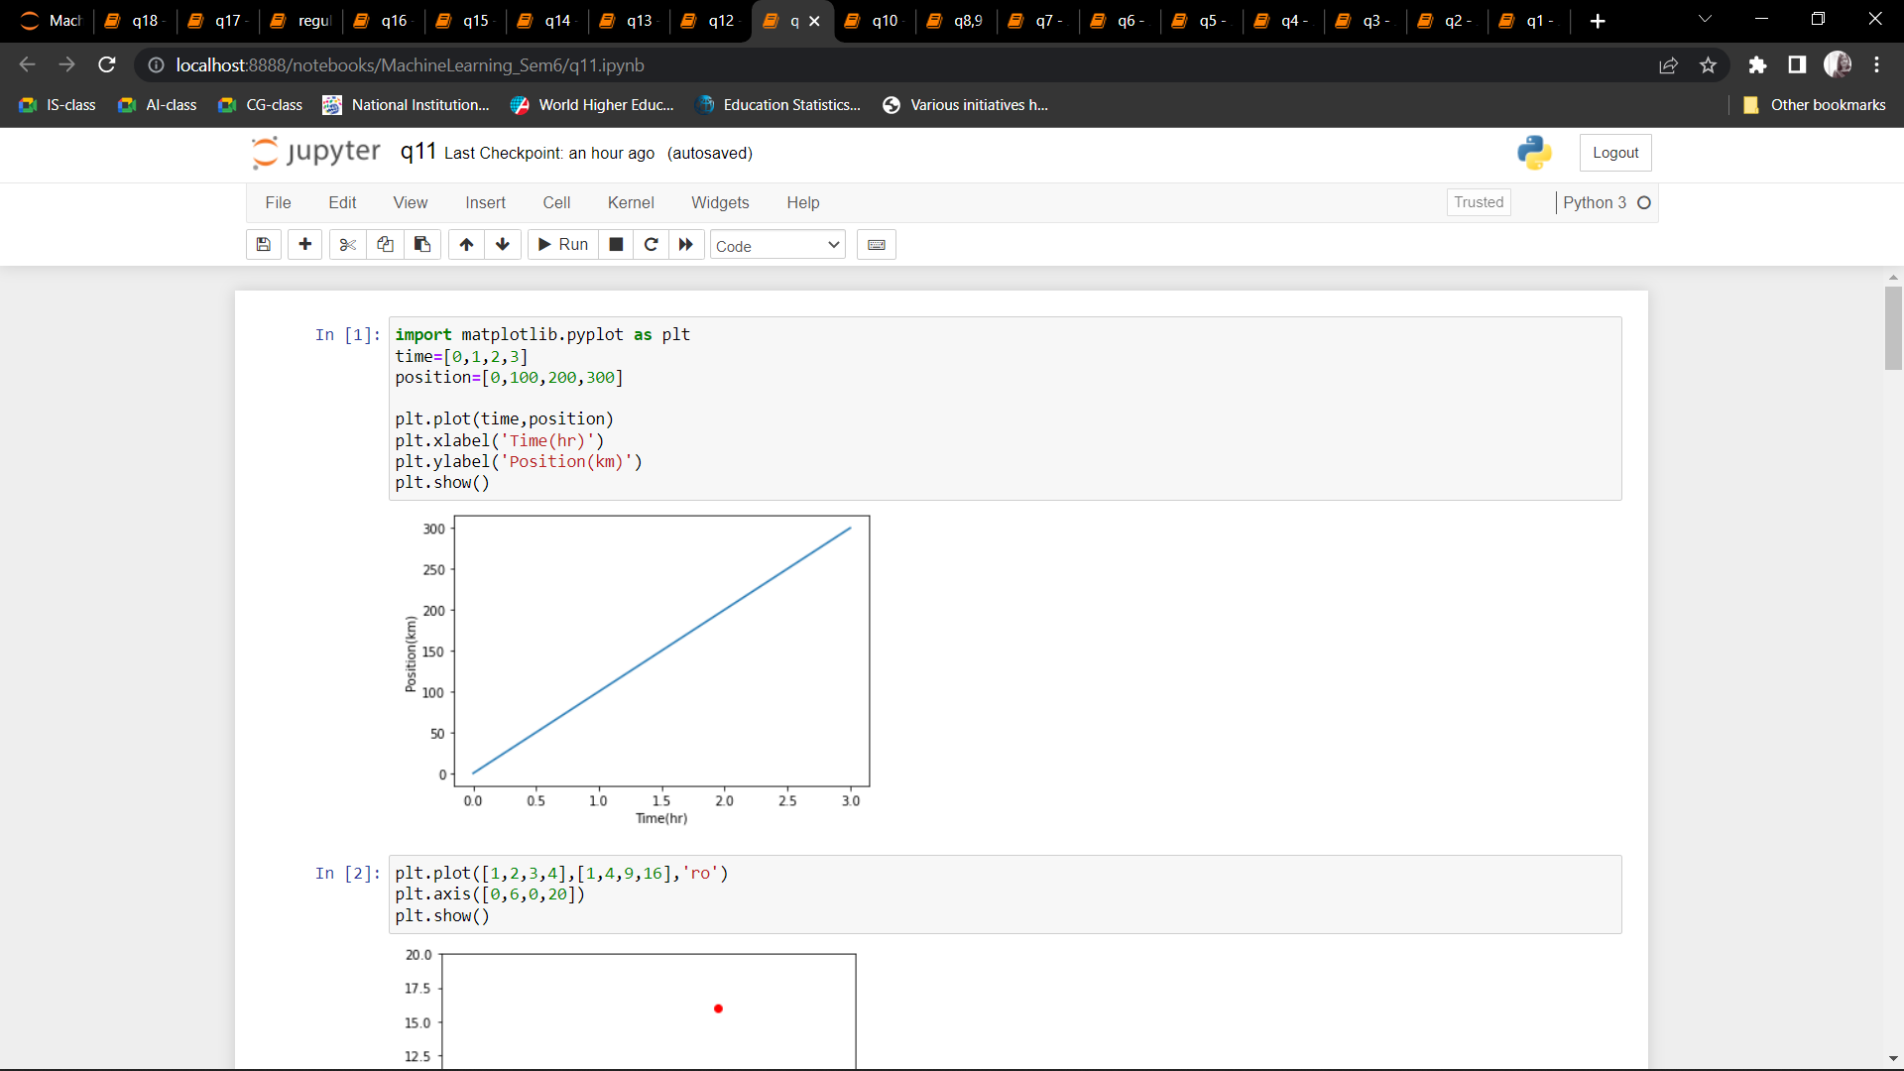 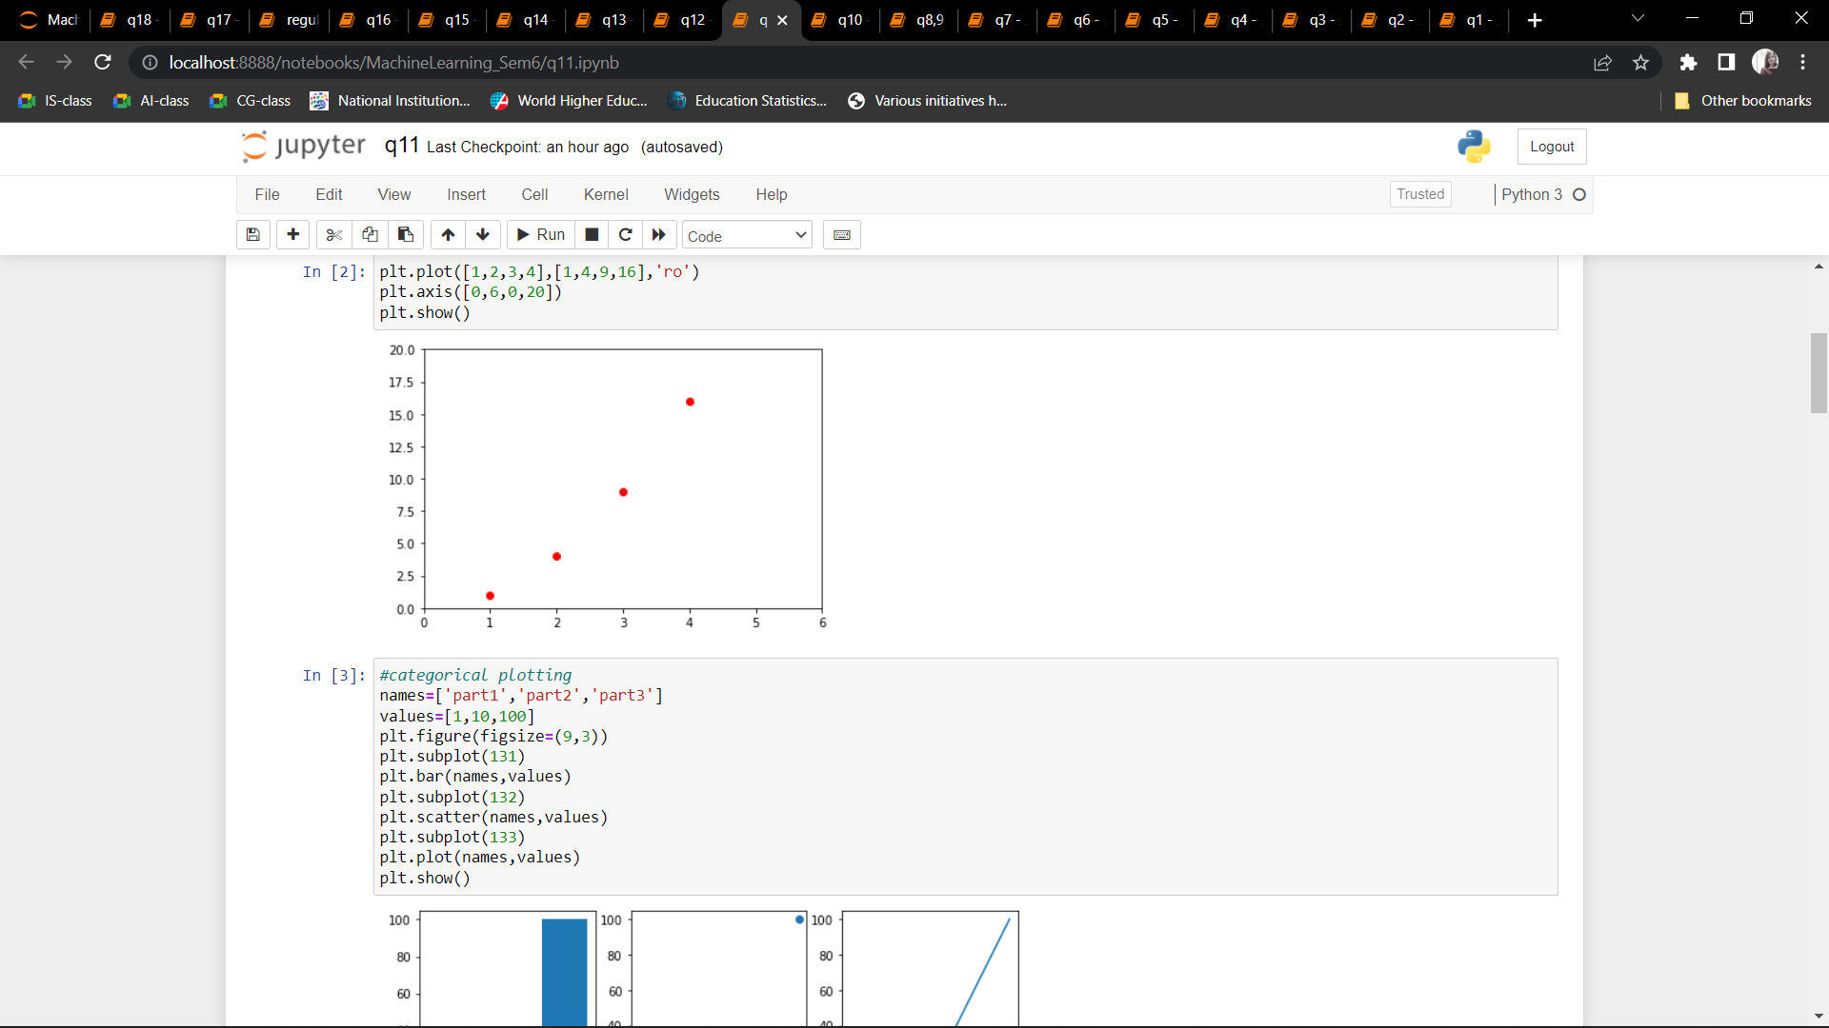 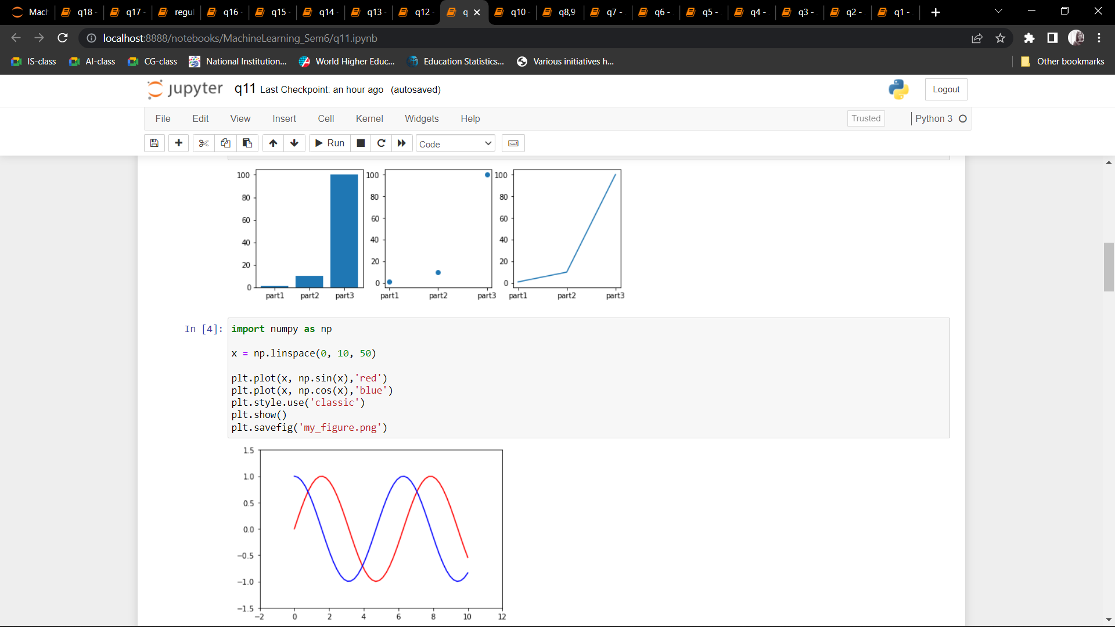 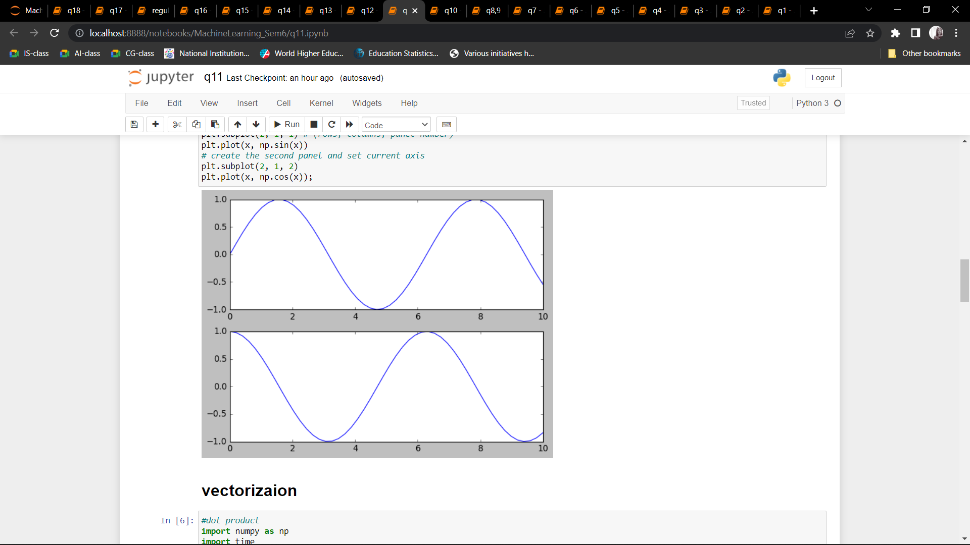 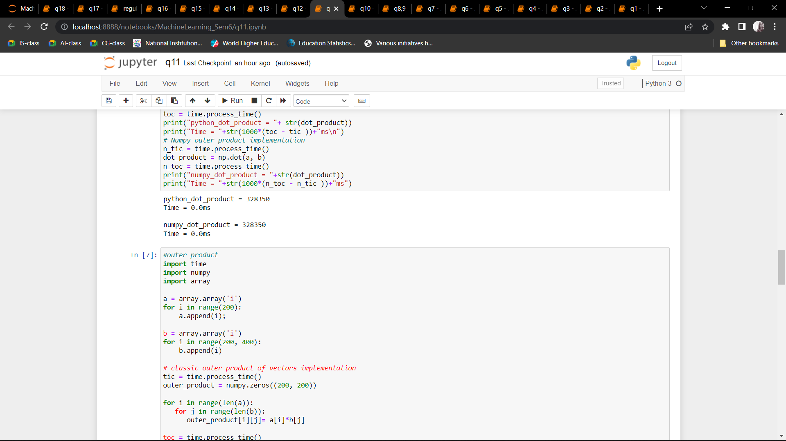 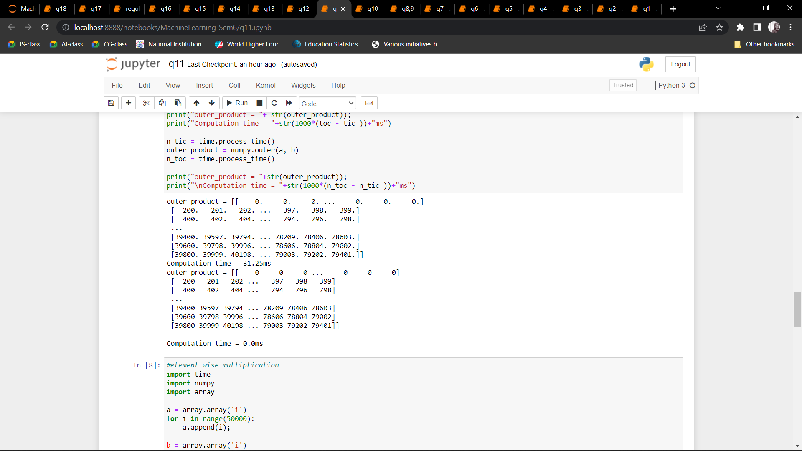 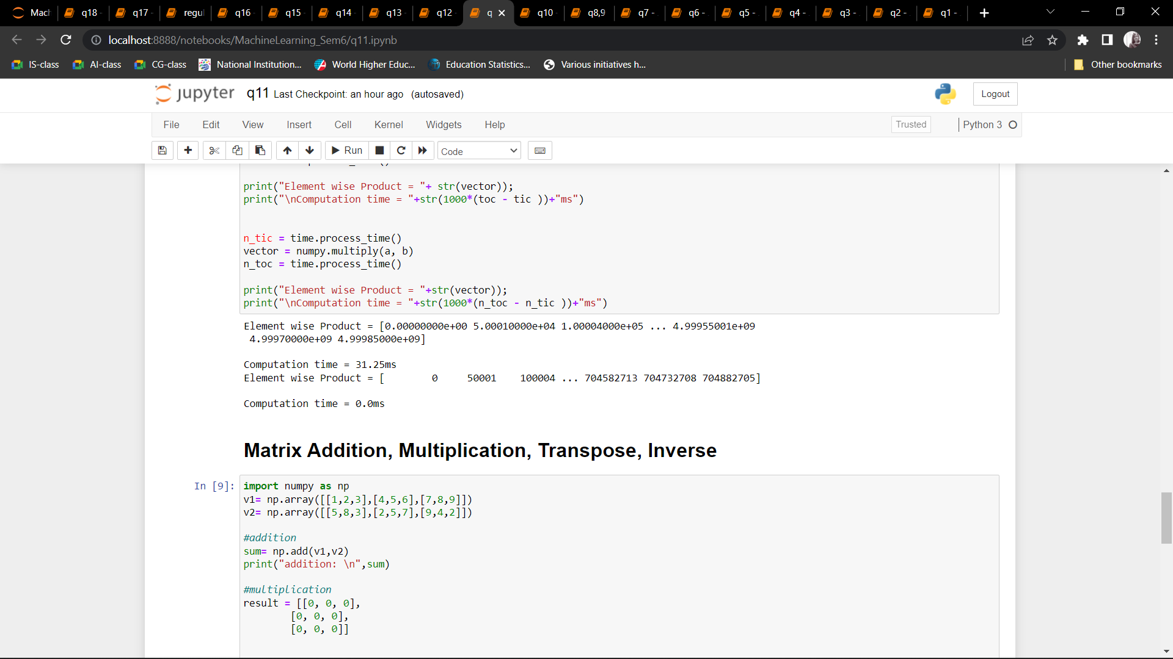 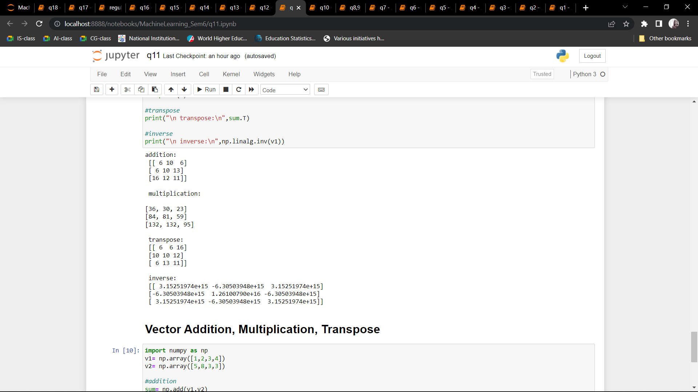 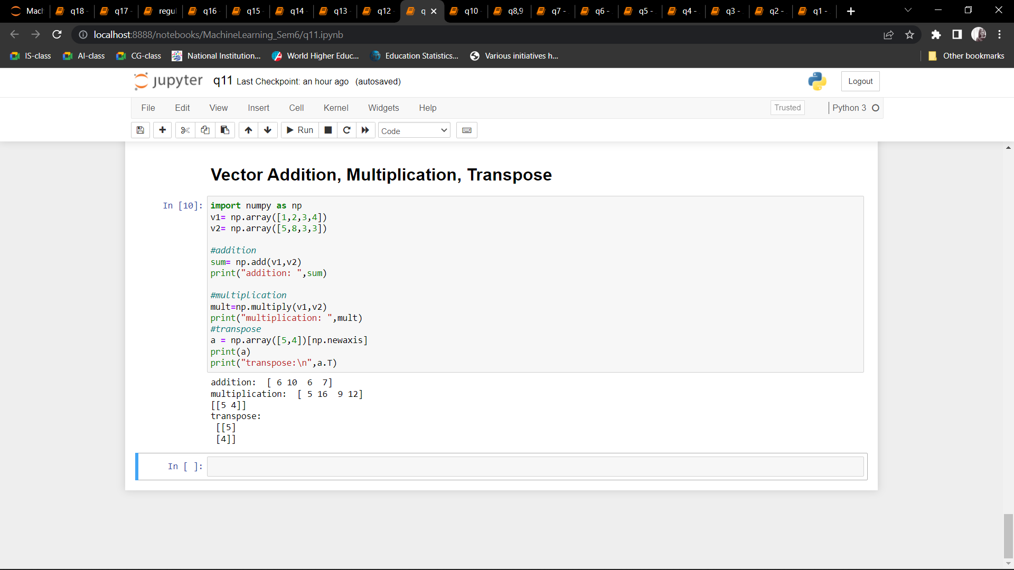

Q12: Implement Linear Regression problem.

CODE:

import pandas as pd

import numpy as np

import matplotlib.pyplot as plt

from sklearn.linear_model import LinearRegression

from sklearn.metrics import r2_score

import statsmodels.api as sm

data = pd.read_csv(r"Advertising.csv")

data

data.head()

data.columns

plt.figure(figsize=(16, 8))

plt.scatter(

data['TV'],

data['sales'],

c='black'

)

plt.xlabel("Money spent on TV ads ($)")

plt.ylabel("Sales ($)")

plt.show()

X = data['TV'].values.reshape(-1,1)

y = data['sales'].values.reshape(-1,1)

from sklearn.model_selection import train_test_split

X_train, X_test, y_train, y_test = train_test_split(X,y,test_size=0.3,random_state=0)

print(X_train.shape)

print(X_test.shape)

print(y_train.shape)

print(y_test.shape)

reg = LinearRegression()

reg.fit(X_train, y_train)

X = data['TV'].values.reshape(-1,1)

y = data['sales'].values.reshape(-1,1)

from sklearn.model_selection import train_test_split

X_train, X_test, y_train, y_test = train_test_split(X,y,test_size=0.3,random_state=0)

print(X_train.shape)

print(X_test.shape)

print(y_train.shape)

print(y_test.shape)

reg = LinearRegression()

reg.fit(X_train, y_train)

print(reg.coef_[0][0])

print(reg.intercept_[0])

print("The linear model is: Y = {:.5} + {:.5}X".format(reg.intercept_[0], reg.coef_[0][0]))

predictions = reg.predict(X_test)

plt.figure(figsize=(16, 8))

plt.scatter(

data['TV'],

data['sales'],

c='black'

)

plt.plot(

X_test,

predictions,

c='blue',

linewidth=2

)

plt.xlabel("Money spent on TV ads ($)")

plt.ylabel("Sales ($)")

plt.show()

X=X_train

y=y_train

X2 = sm.add_constant(X)

est = sm.OLS(y, X2)

est2 = est.fit()

print(est2.summary())

print('Train Score :', reg.score(X_train,y_train))

print('Test Score:', reg.score(X_test,y_test))

from sklearn import metrics

print('MSE :', metrics.mean_squared_error(y_test,predictions))

print('RMSE :', np.sqrt(metrics.mean_squared_error(y_test,predictions)))

OUTPUT: 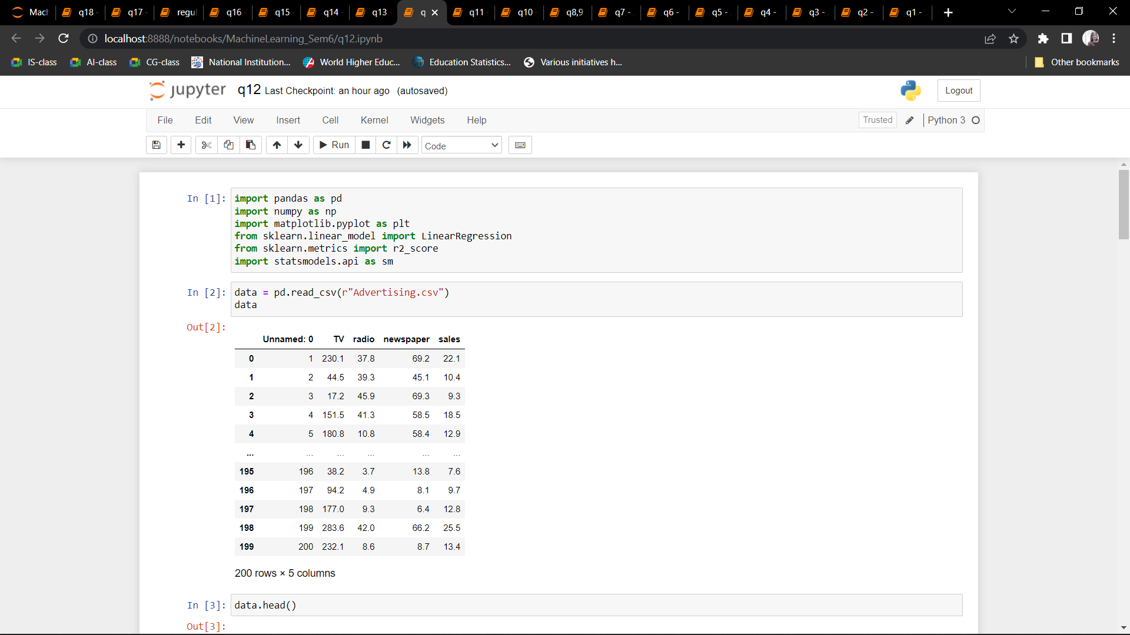 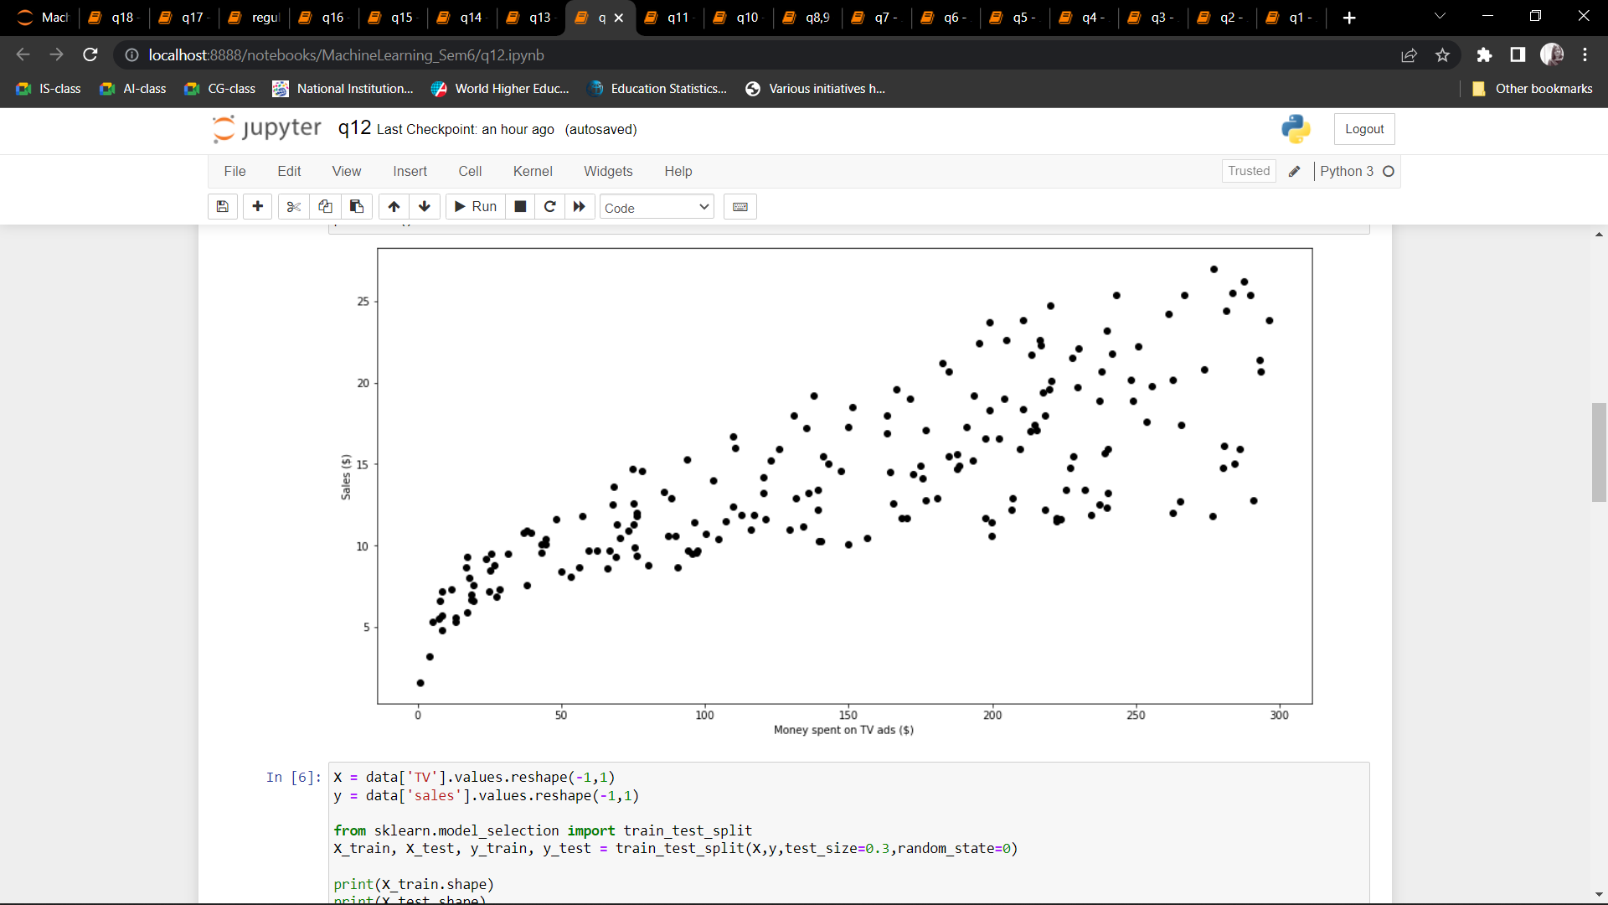 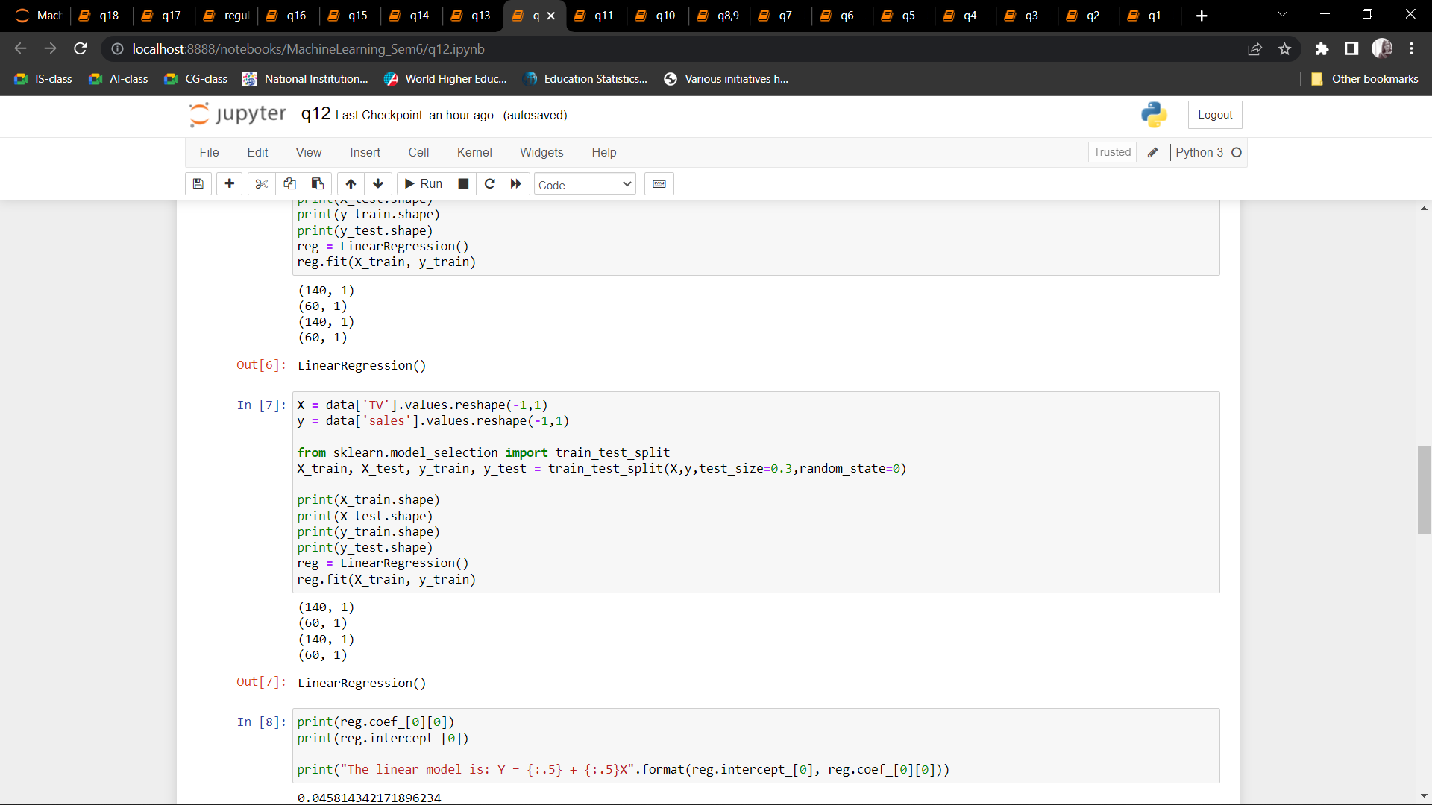 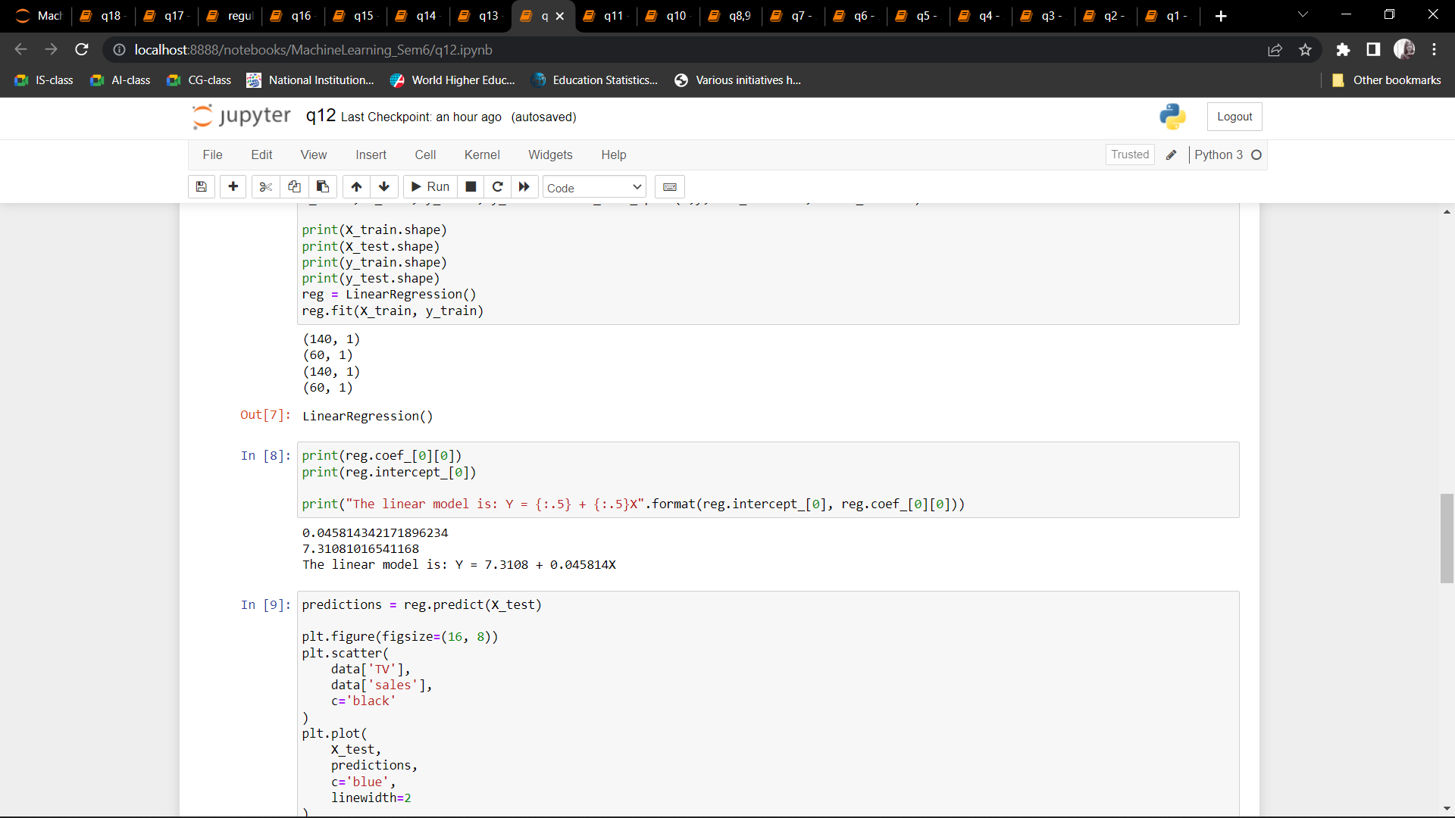 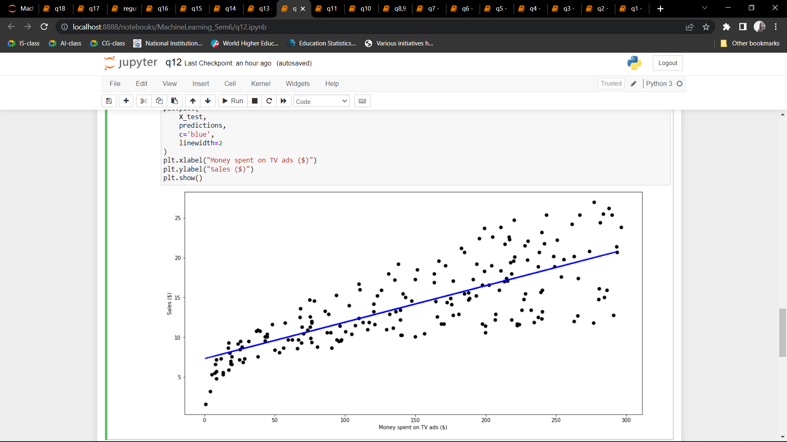 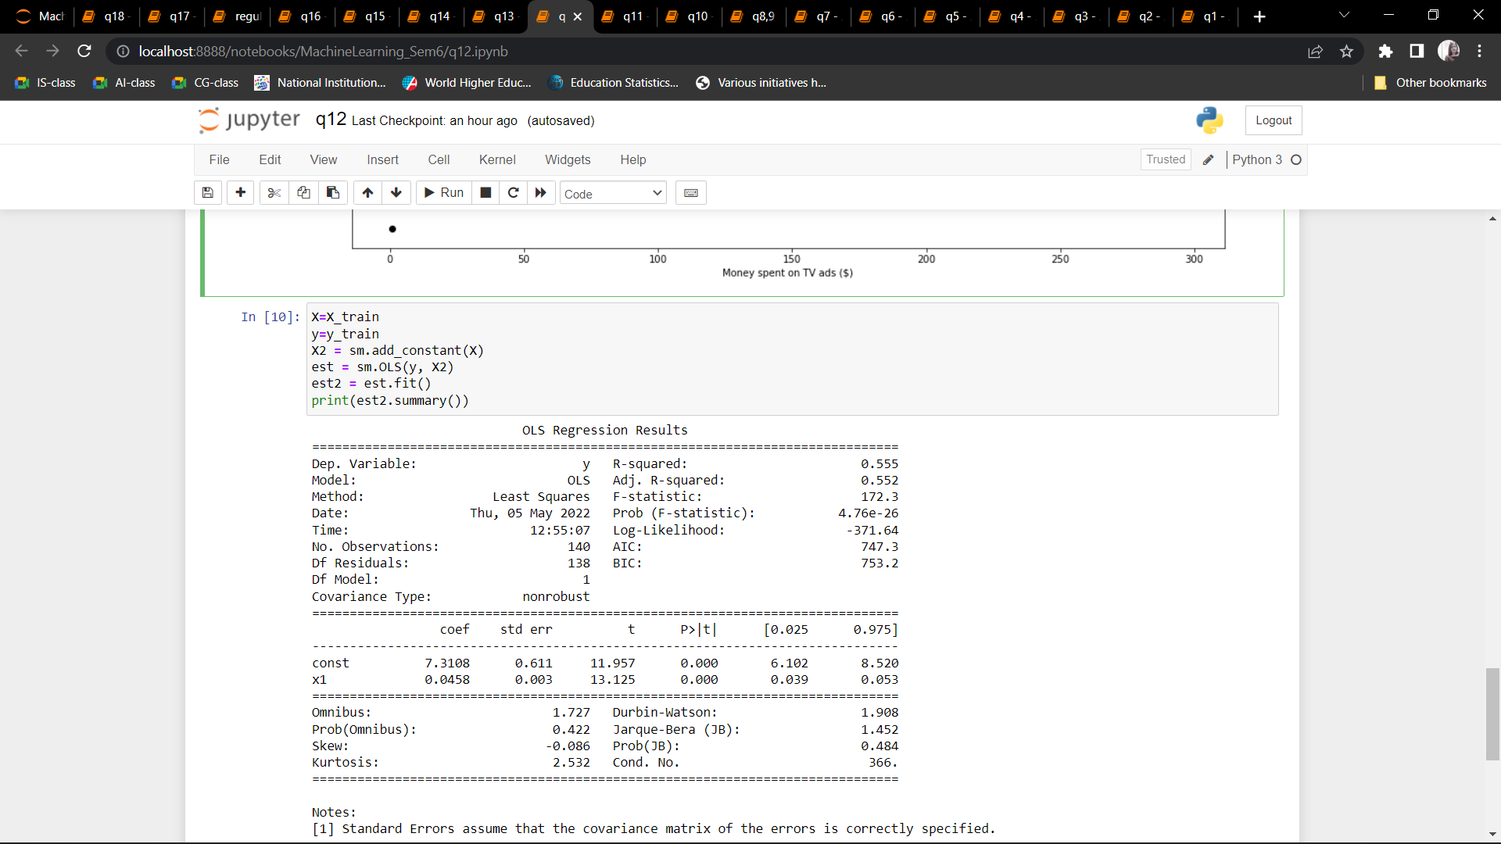 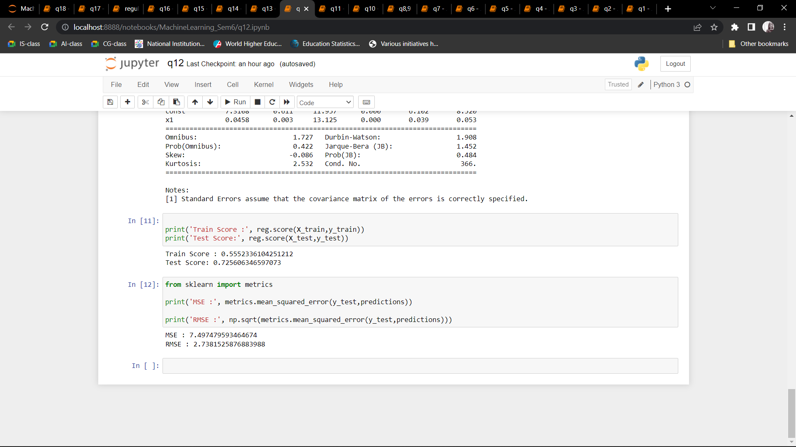

Q13: Based on multiple features/variables perform Linear Regression.

CODE:

import pandas as pd

import numpy as np

import matplotlib.pyplot as plt

from sklearn.linear_model import LinearRegression

from sklearn.metrics import r2_score

import statsmodels.api as sm

data = pd.read_csv(r"Advertising.csv")

data.head()

Xs = data.drop(['sales', 'Unnamed: 0'], axis=1)

y = data['sales'].values.reshape(-1,1)

reg = LinearRegression()

reg.fit(Xs, y)

print("The linear model is: Y = {:.5} + {:.5}*TV + {:.5}*radio + {:.5}*newspaper".format(reg.intercept_[0], reg.coef_[0][0], reg.coef_[0][1], reg.coef_[0][2]))

X = np.column_stack((data['TV'], data['radio'], data['newspaper']))

y = data['sales']

X2 = sm.add_constant(X)

est = sm.OLS(y, X2)

est2 = est.fit()

print(est2.summary())

OUTPUT: 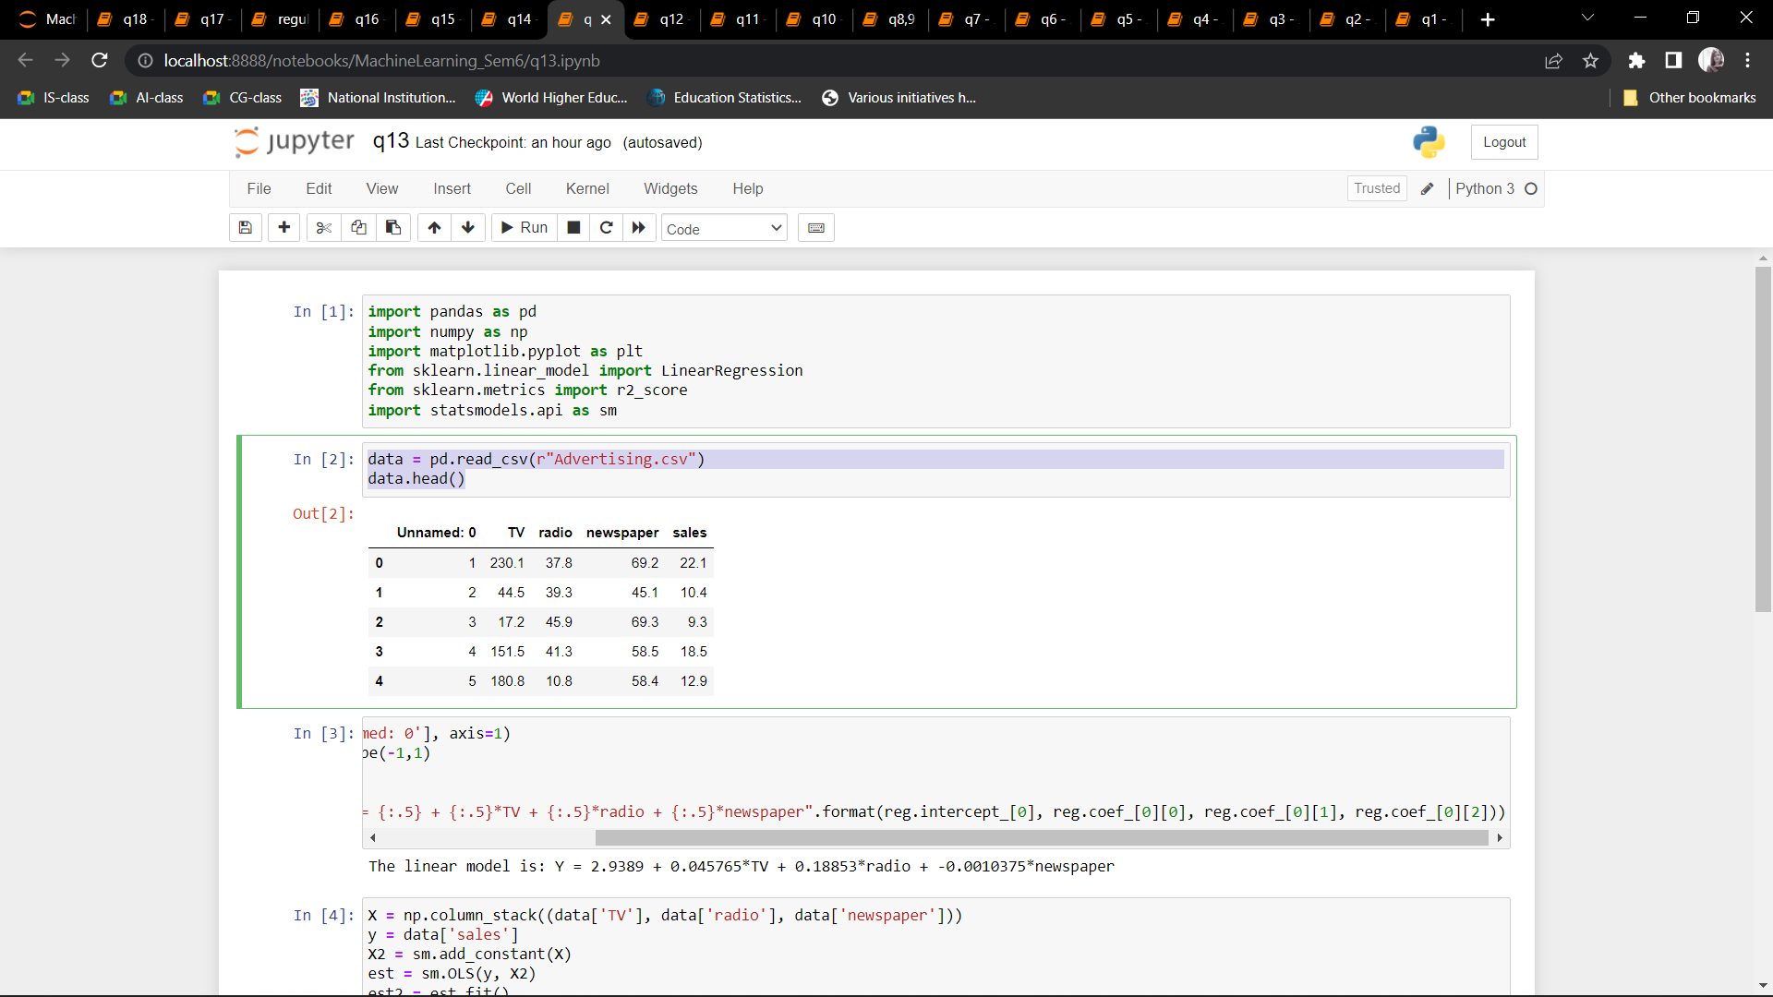 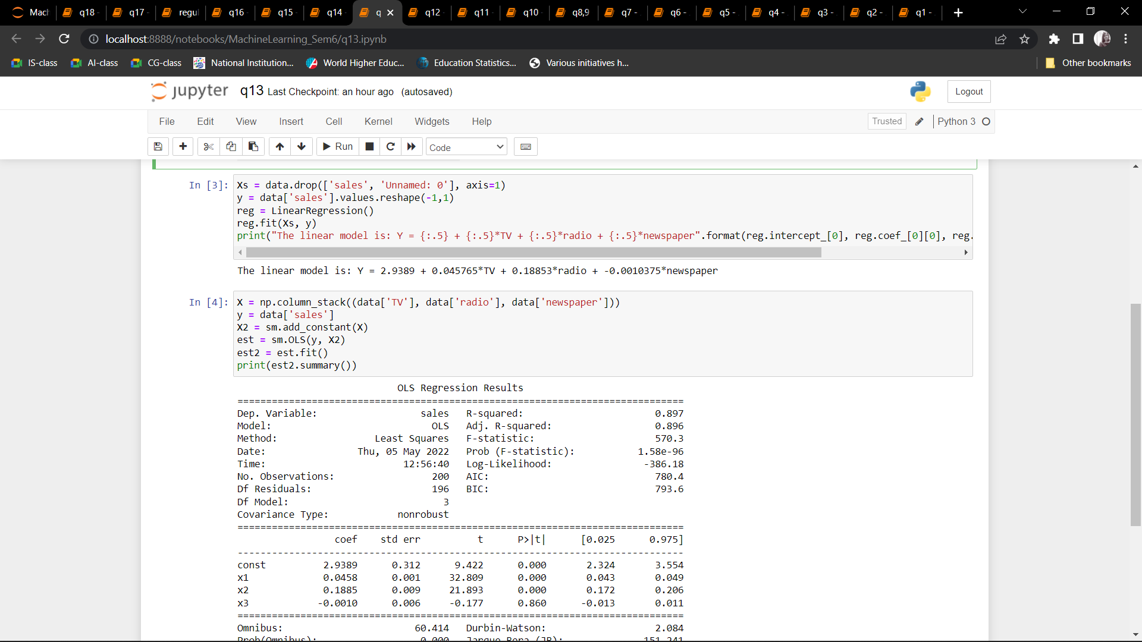 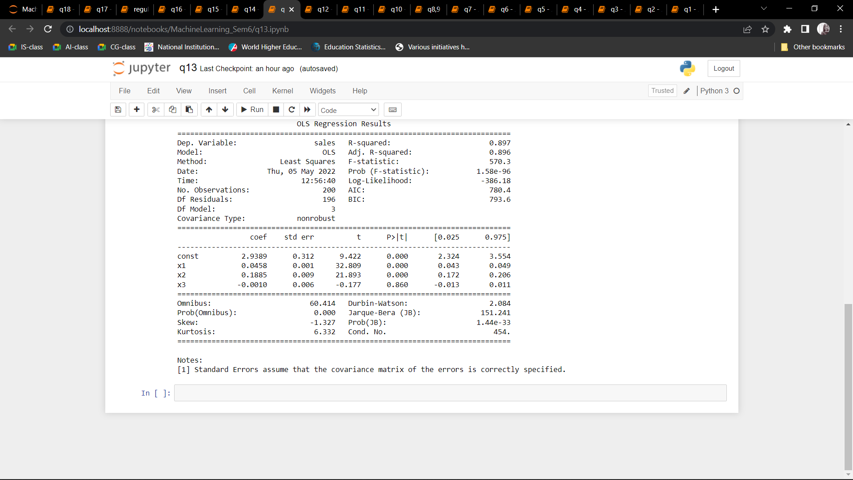

Q14: Implement a classification/ logistic regression problem.

CODE:

import pandas as pd

from matplotlib import pyplot as plt

%matplotlib inline

from sklearn.datasets import load_breast_cancer

df = load_breast_cancer()

from sklearn.model_selection import train_test_split

#X_train, X_test, y_train, y_test = train_test_split(df[['age']],df.bought_insurance,train_size=0.9)

X_train, X_test, y_train, y_test = train_test_split(df.data,df.target,test_size=0.2, stratify=df.target,random_state=42)

X_test.shape

from sklearn.linear_model import LogisticRegression

model = LogisticRegression(C=0.1)

model.fit(X_train, y_train)

y_predicted = model.predict(X_test)

from sklearn.metrics import confusion_matrix

confusion_matrix(y_test,y_predicted)

OUTPUT: 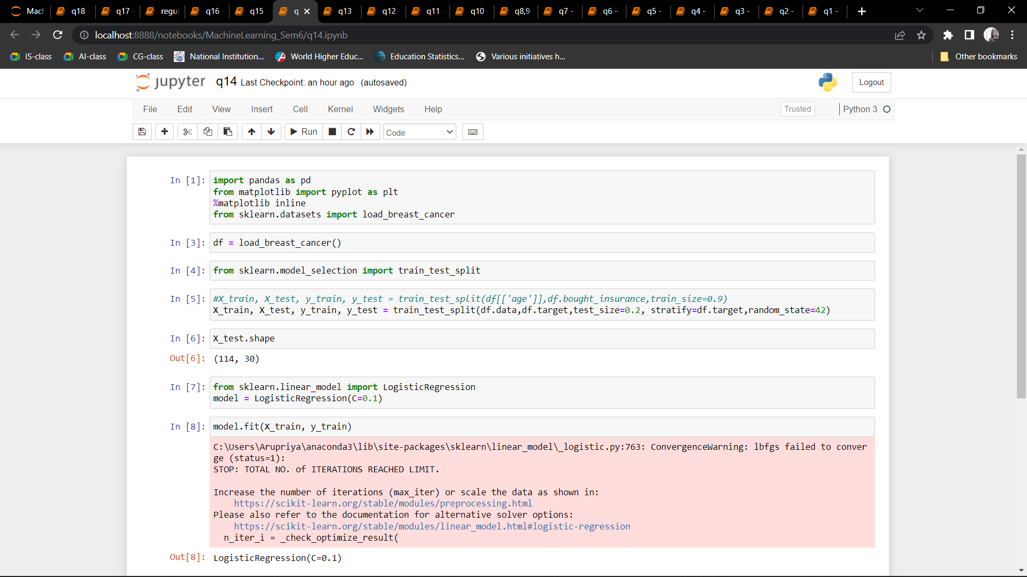 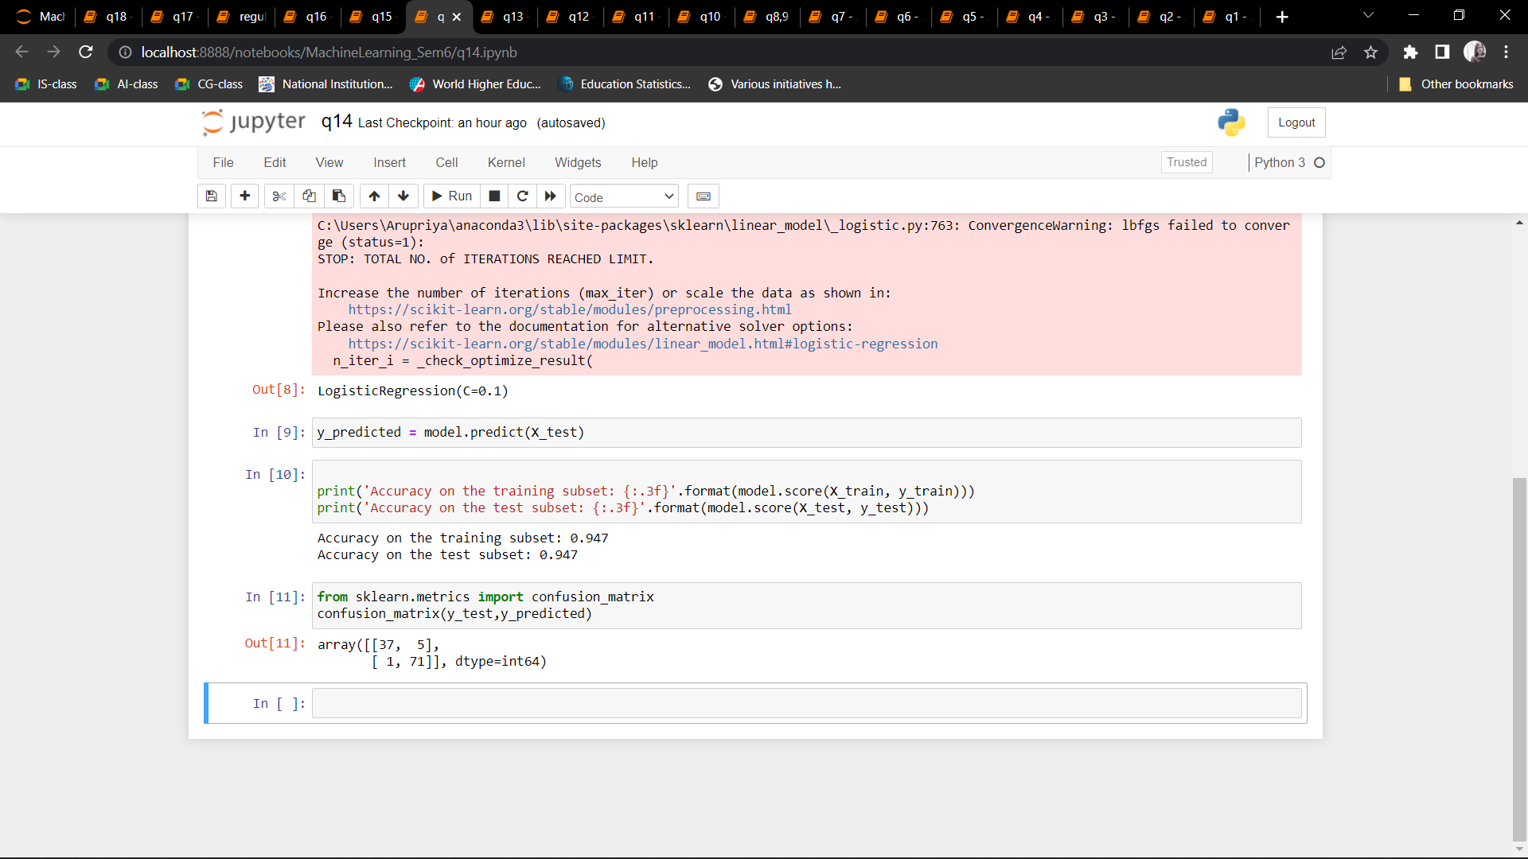

Q15: Use some function for regularization of dataset based on problem 14.

CODE:

import pandas as pd

from sklearn.model_selection import train_test_split

from sklearn.linear_model import LinearRegression, Lasso, Ridge

from sklearn.metrics import mean_squared_error

colnames = ["CRIM", "ZN", "INDUS", "CHAS", "NOS", "RM", "AGE","DIS","RAD","TAX", "PTRATIO","B","LSTAT","MEDV"]

df = pd.read_csv('housing.csv', delim_whitespace=True, header=None, names=colnames).head(100)

print(df)

target= ["MEDV"]

features = ["CRIM", "ZN", "INDUS", "CHAS", "NOS", "RM", "AGE","DIS","RAD","TAX", "PTRATIO","B","LSTAT"]

y = df[target]

X = df[features]

X_train, X_test, y_train, y_test = train_test_split(X, y, test_size = 0.2, random_state=5)

print(X_train.shape)

print(X_test.shape)

print(y_train.shape)

print(y_test.shape)

linear_reg = LinearRegression()

linear_reg.fit(X_train, y_train)

y_pred = linear_reg.predict(X_test)

mse_linear = mean_squared_error(y_pred, y_test)

print(mse_linear)

print(linear_reg.coef_)

lambda_values = [0.000001, 0.0001, 0.001, 0.005, 0.01, 0.05, 0.1, 0.2, 0.3, 0.4, 0.5]

for lambda_val in lambda_values:

lasso_reg = Lasso(lambda_val)

lasso_reg.fit(X_train, y_train)

y_pred = lasso_reg.predict(X_test)

mse_lasso = mean_squared_error(y_pred, y_test)

print(("Lasso MSE with Lambda={} is {}").format(lambda_val, mse_lasso))

print(lasso_reg.coef_)

lambda_values = [0.00001, 0.01, 0.05, 0.1, 0.5, 1, 1.5, 3, 5, 6, 7, 8, 9, 10]

for lambda_val in lambda_values:

ridge_reg = Ridge(lambda_val)

ridge_reg.fit(X_train, y_train)

y_pred = ridge_reg.predict(X_test)

mse_ridge = mean_squared_error(y_pred, y_test)

print(("Lasso MSE with Lambda={} is {}").format(lambda_val, mse_ridge))

print(ridge_reg.coef_)

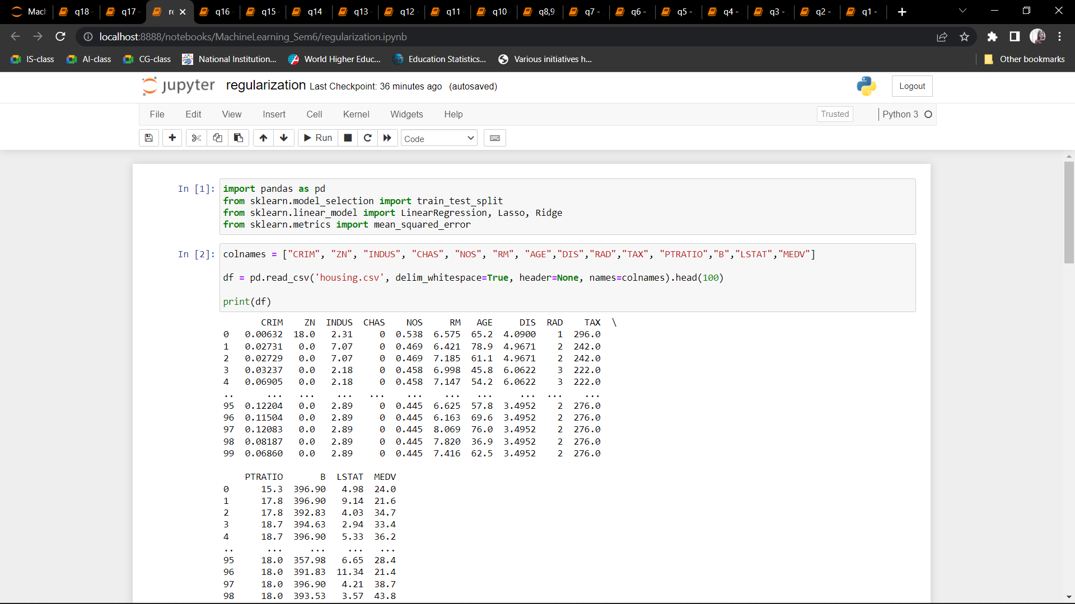 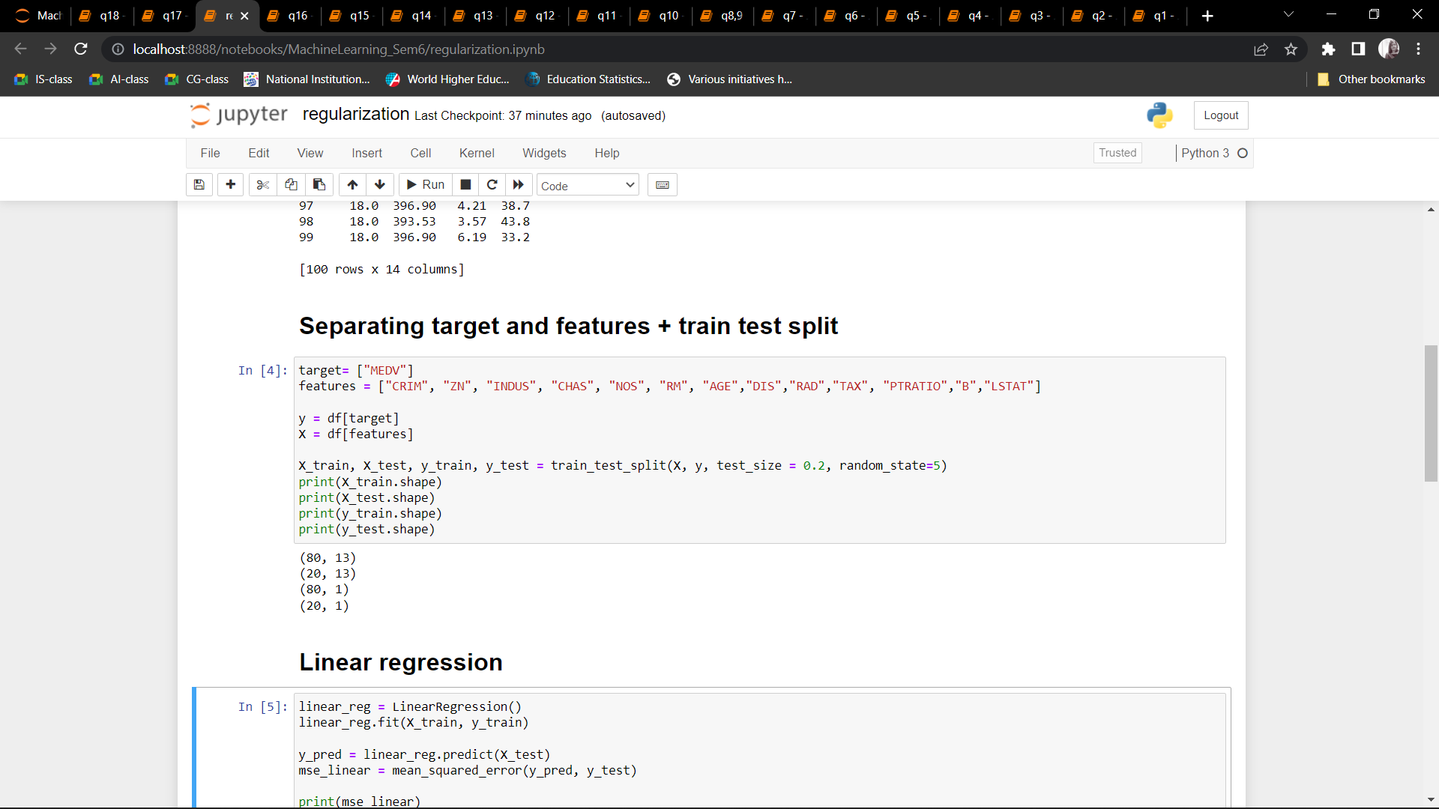 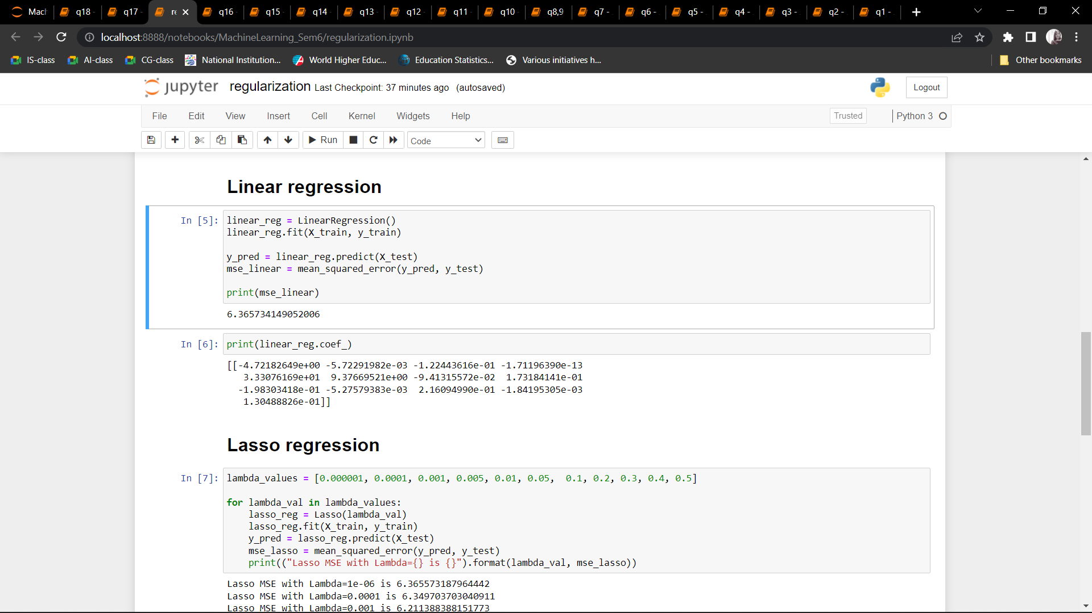 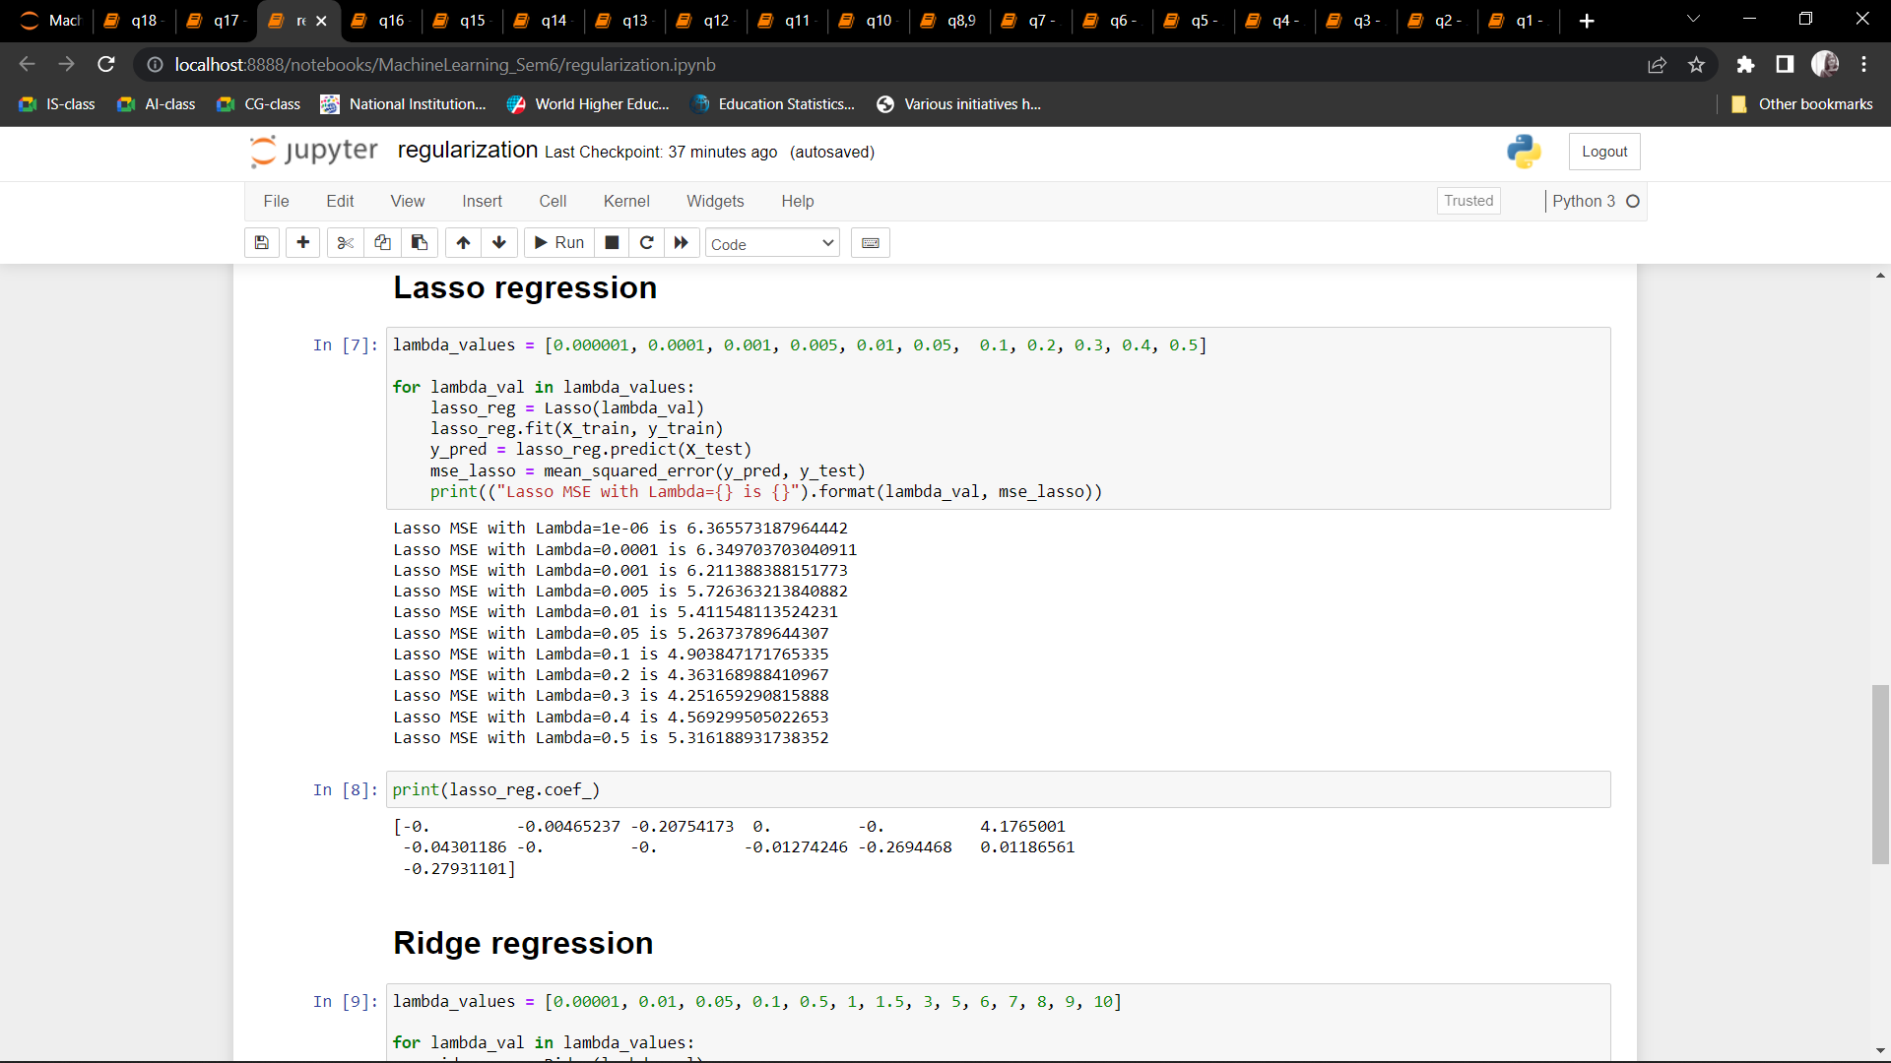 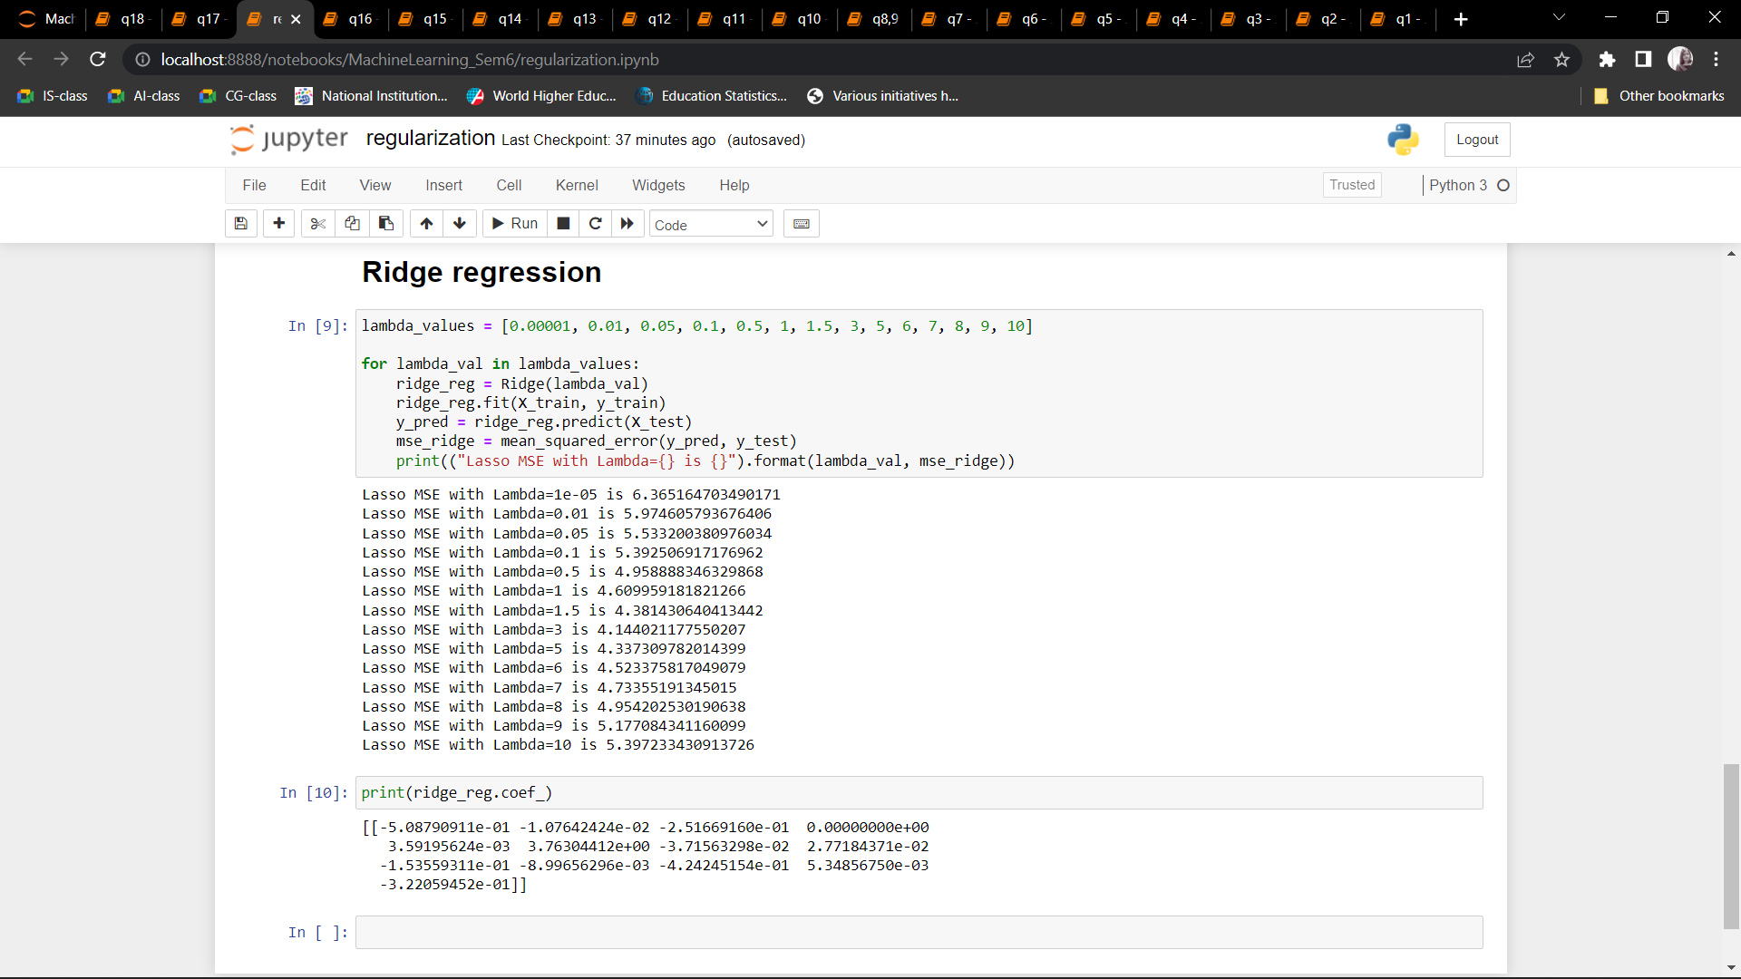

Q16: Use some function for neural networks, like Stochastic Gradient Descent or backpropagation - algorithm to predict the value of a variable based on the dataset of problem 14.

CODE:

from numpy import*

import pandas as pd

from sklearn.neural_network import MLPClassifier

from sklearn.model_selection import train_test_split

df= pd.read_csv(r"diabetes.csv")

df.head()

X_train, X_test, y_train, y_test = train_test_split(df.data,df.target,test_size=0.2,random_state=4)

y_test

nn=MLPClassifier(activation='logistic', hidden_layer_sizes=(10,10,10), random_state=5, verbose=True, solver='sgd',learning_rate_init=0.001)

nn.fit(X_train,y_train)

pred=nn.predict(X_test)

pred

from sklearn.metrics import accuracy_score

accuracy_score(y_test,pred)

OUTPUT: 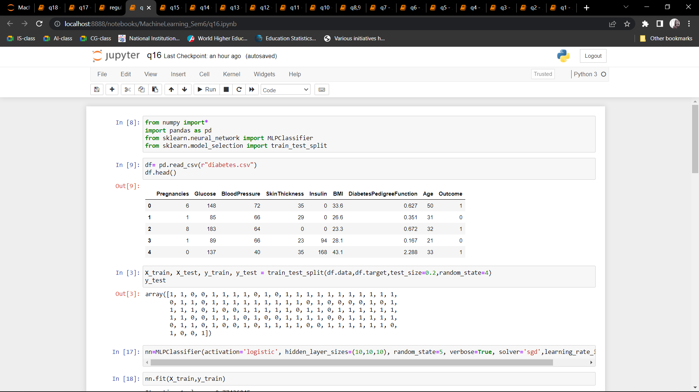 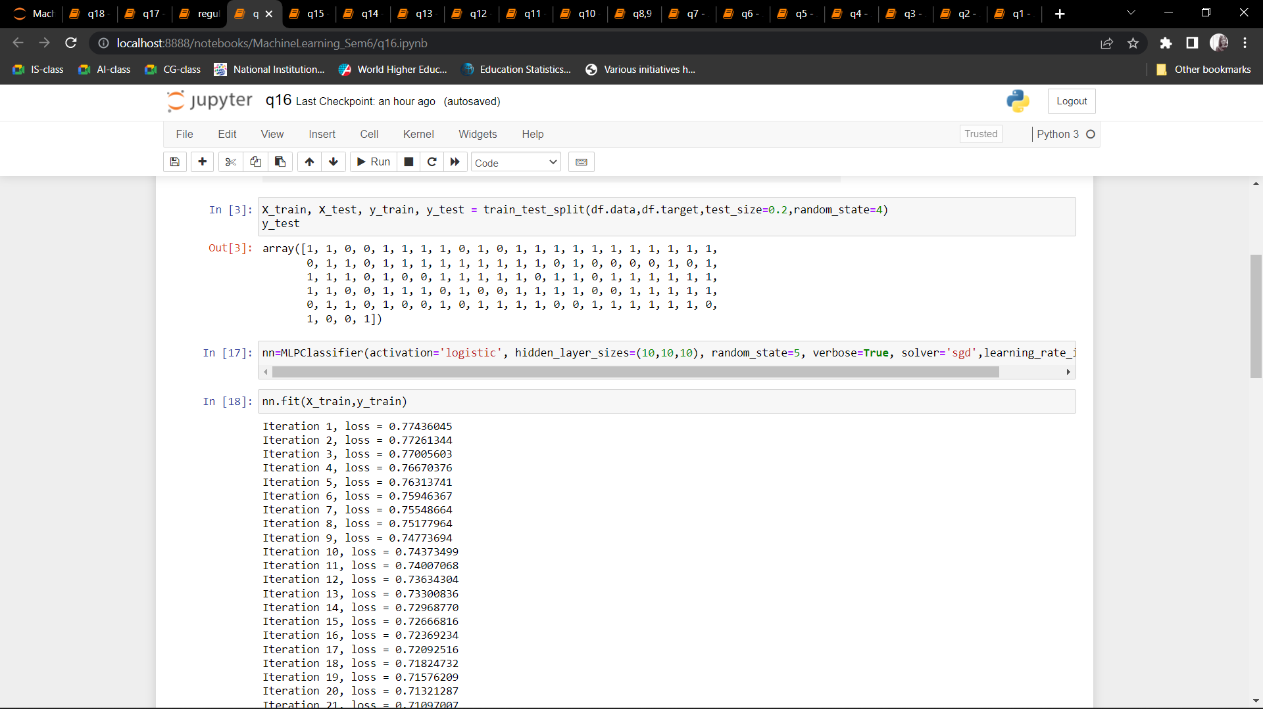 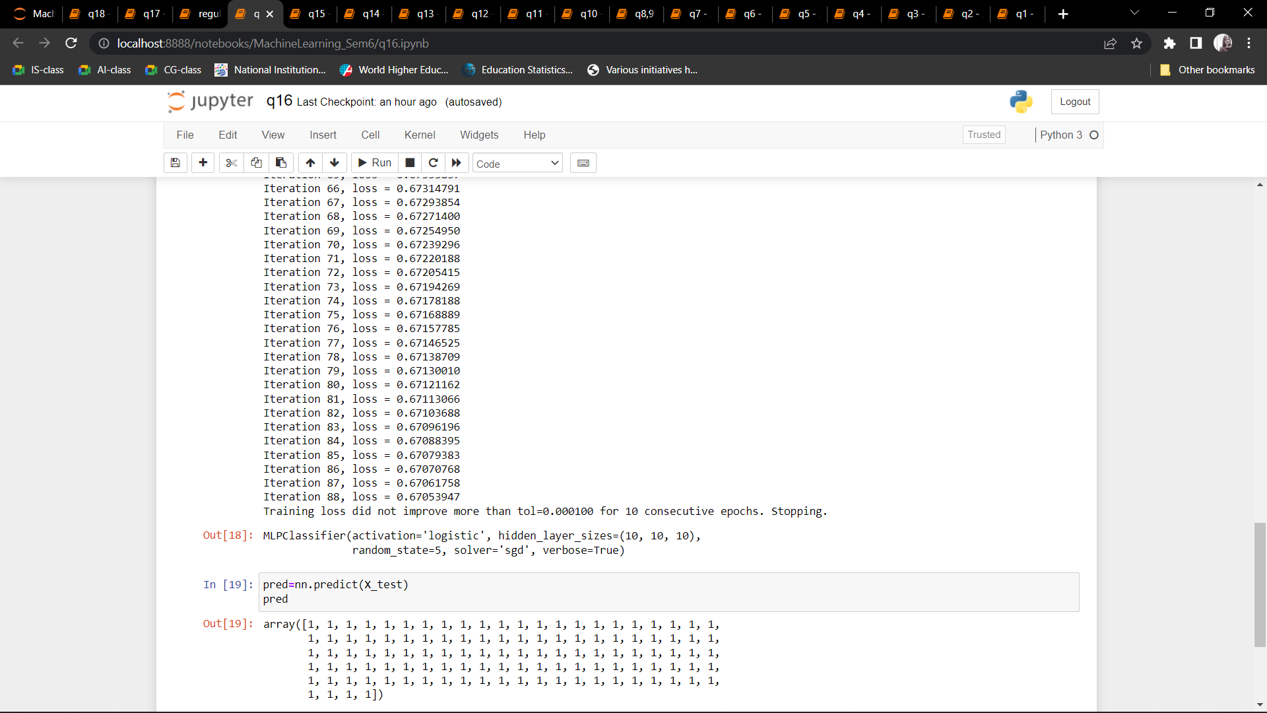 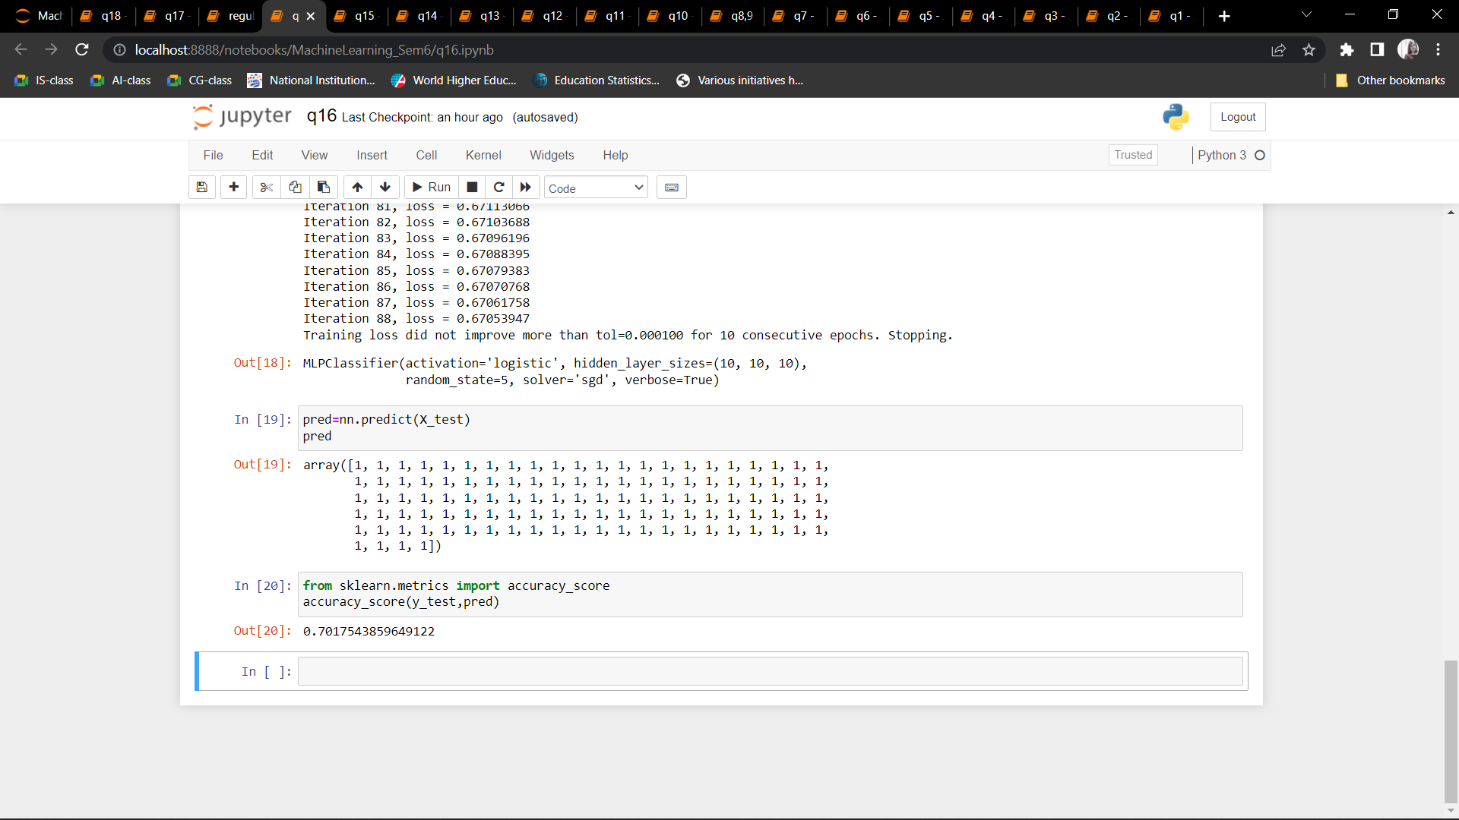

Q17: Implement Simple linear regression using least squared method.

CODE:

from sklearn.datasets import make_regression

from matplotlib import pyplot as plt

import numpy as np

from sklearn.linear_model import LinearRegression

X, y, coefficients = make_regression(

n_samples=50,

n_features=1,

n_informative=1,

n_targets=1,

noise=5,

coef=True,

random_state=1

)

n = X.shape[1]

r = np.linalg.matrix_rank(X)

U, sigma, VT = np.linalg.svd(X, full_matrices=False)

D_plus = np.diag(np.hstack([1/sigma[:r], np.zeros(n-r)]))

V = VT.T

X_plus = V.dot(D_plus).dot(U.T)

w = X_plus.dot(y)

error = np.linalg.norm(X.dot(w) - y, ord=2) ** 2

np.linalg.lstsq(X, y)

plt.scatter(X, y)

plt.plot(X, w*X, c='orange')

lr = LinearRegression()

lr.fit(X, y)

w = lr.coef_[0]

plt.scatter(X, y)

plt.plot(X, w*X, c='orange')

OUTPUT: 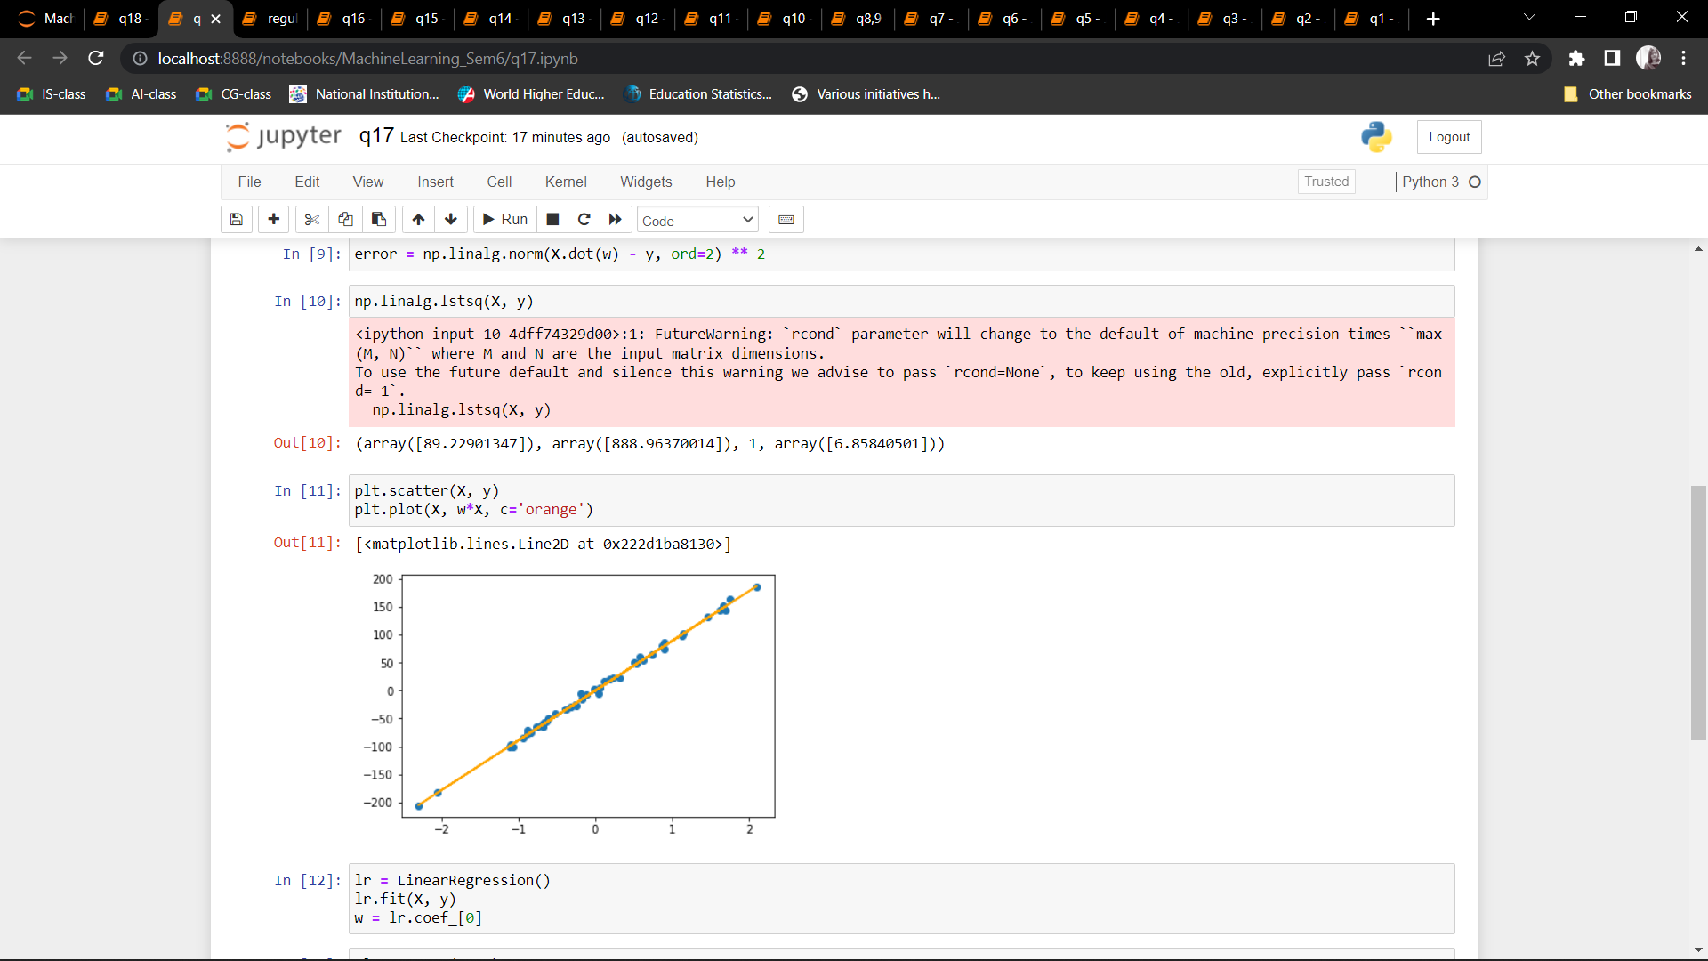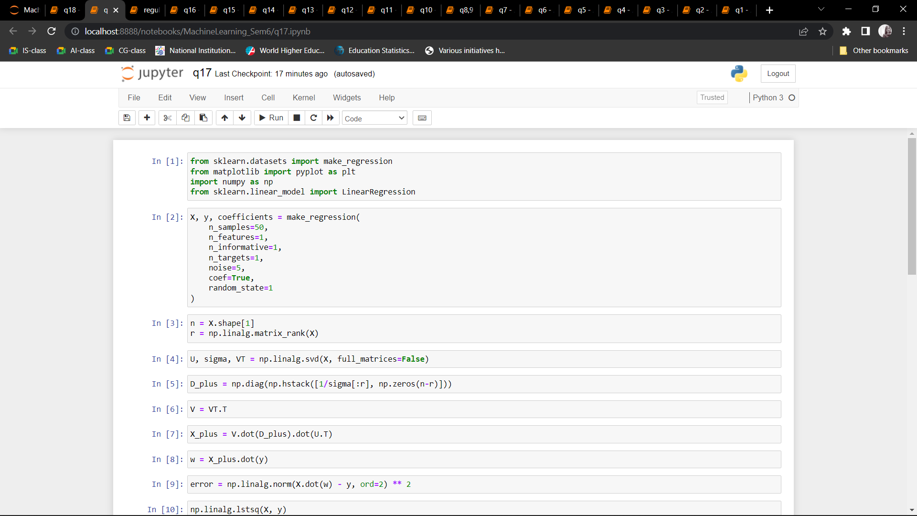 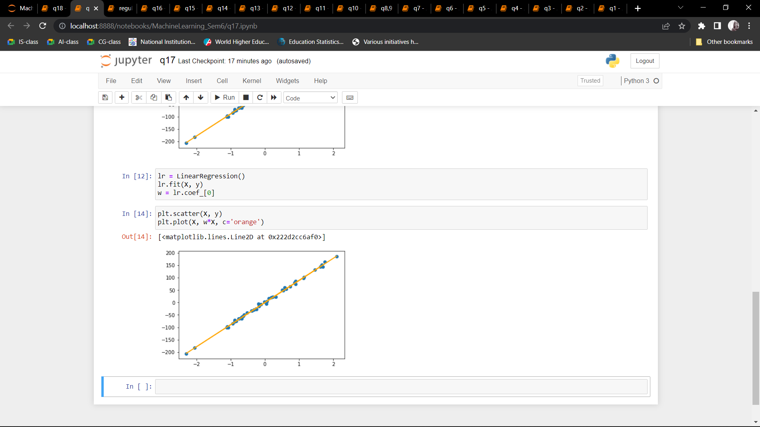

Q18: Implement multiple linear regression using normal equation method.

CODE:

import numpy as np

import pandas as pd

import matplotlib.pyplot as plt

col_list = ["TV", "radio","newspaper","sales"]

data = pd.read_csv("Advertising.csv", usecols=col_list)

data["sales"] #y-axis

data["radio"] #x-axis

x_mean=np.mean(data["radio"])

print(x_mean)

y_mean=np.mean(data["sales"])

print(y_mean)

n=data["sales"].size

print(n)

ss_xy=np.sum(data["radio"]*data["sales"]) - n*x_mean*y_mean

print(ss_xy)

ss_xx=np.sum(data["radio"]*data["radio"]) - n*x_mean*x_mean

print(ss_xx)

b1=ss_xy/ss_xx

print(b1)

b0=y_mean-b1*x_mean

print(b0)

plt.scatter(data["radio"],data["sales"])

y_pred=b0+b1*data["radio"]

print(y_pred)

plt.plot(data["radio"],y_pred,color='red')

plt.xlabel("radio")

plt.ylabel("sales")

plt.title("Linear Regression[Sales~Radio]")

plt.show()

e=data["sales"]-y_pred

e

RSS=np.sum(e**2)

RSS

MSE=RSS/n

MSE

SST=np.sum((data["sales"]-y_mean)**2)

SST

R2=1-(RSS/SST)

R2

##REGRESS SALES~RADIO, TV, NEWSPAPER FROM ADVERTISING.CSV

import pandas as pd

import numpy as np

import statistics

import math

import statsmodels.api as sm

import matplotlib.pyplot as plt

from mpl_toolkits.mplot3d import axes3d

ds=pd.read_csv("Advertising.csv")

x1=ds.TV.values

#print(x1.shape)

x1=x1.reshape(200,1)

#print(x1.shape)

x2=ds.radio.values

x2=x2.reshape(200,1)

x3=ds.newspaper.values

x3=x3.reshape(200,1)

x0=np.ones([200,1])

X=np.column_stack((x0,x1,x2,x3))

print(X)

y=ds.sales.values

Y=y.reshape(200,1)

Xt=np.transpose(X)

print(Xt.shape)

XtX=np.matmul(Xt,X)

print(XtX.shape)

XtX_inv=np.linalg.inv(XtX)

print(XtX_inv.shape)

prod=np.matmul(XtX_inv,Xt)

theta=np.matmul(prod,Y)

theta

y_pred=np.matmul(X,theta)

e=Y-y_pred

e.shape

e2=e**2

e2

RSS=np.sum(e2)

RSS

MSE=np.mean(e2)

MSE

y_mean=np.mean(Y)

y_mean

Y-y_mean

SST=np.sum((Y-y_mean)**2)

SST

fig = plt.figure()

ax = plt.axes(projection='3d')

ax.scatter3D(x1, x2, y_pred);

ax.set_xlabel('x1')

ax.set_ylabel('x2')

ax.set_zlabel('y_pred');

a = np.column_stack((x0,x1))

b = np.column_stack((x0,x2))

c = np.column_stack((x0,y))

fig = plt.figure(num=1, clear=True)

ax = fig.add_subplot(1, 1, 1, projection='3d')

ax.plot_surface(a, b, c)

ax.scatter3D(x1, x2, Y,color='orange');

ax.set(xlabel='x1', ylabel='x2', zlabel='y')

R2=1-(RSS/SST)

R2

OUTPUT: 